Quadrilaterals and Polygons Name ___________________
Trapezoids (6-6) Notes
A quadrilateral that has at least one pair of parallel sides is called a _____________________________. The
sides that are parallel are called ___________________. The nonparallel sides are called
______________________. If the legs are congruent, then it is an ___________________________.
Example: Find m<J and m<L
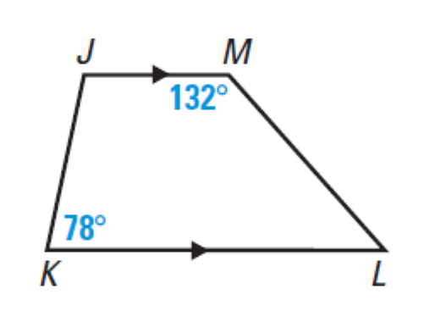

ISOSCELES TRAPEZOIDS
- Each pair of base angles of an isosceles trapezoid are ___________________.

- The diagonals of an isosceles trapezoid are ____________________.

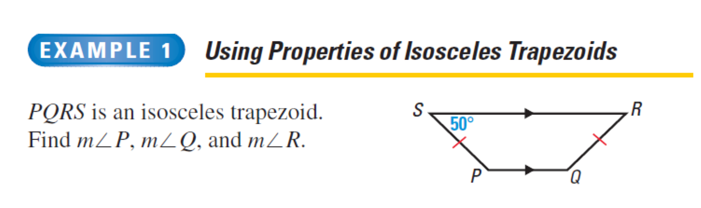

Show that ABCD is a trapezoid. Is it an isosceles trapezoid?

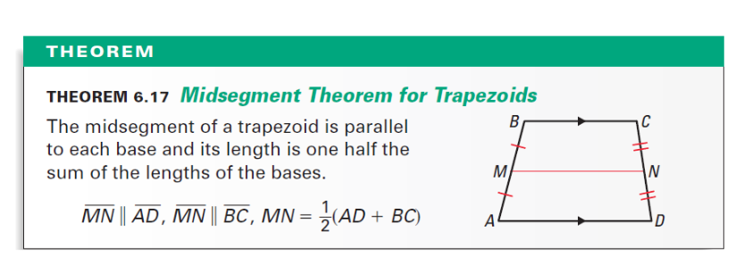
The segment that joins the midpoints of the legs of a trapezoid is called the _________________________.

