Triangle Inequalities Homework #2
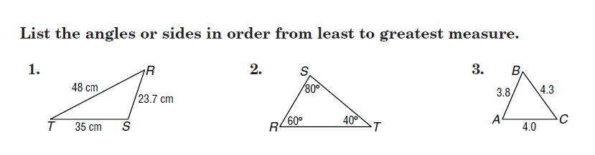

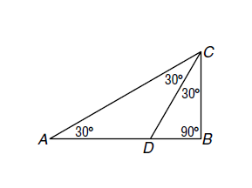

4.

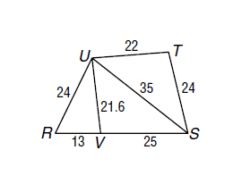

5.

Advanced Triangle Practice Homework

Use figure one for #1-4.

1. Right 2. Obtuse
Figure One

3. Scalene 4. Isosceles

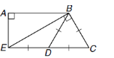

Use figure two for #5 – 8.

5. Right 6. Obtuse
Figure Two

7. Scalene 8. Isosceles

Use the Triangle Sum Theorem to find the numbered angles listed below each figure.

<1= _____ m<1= ______ m<1= ______ m<1= _______
m<2= ______ m<2= _______
m<3= _______
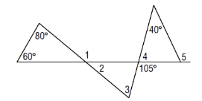
7.

m<1= _______ m<1= _______
m<1= ______ m<2 = _________
m<3= ______ m< 4= __________
m<5 = ______

