Name: _______________________________________________________________________________
7.3 Triangle Similarity Homework

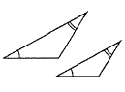
Directions: Determine whether the pairs of triangles are similar by AA Similarity.
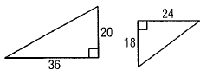
1. 2.

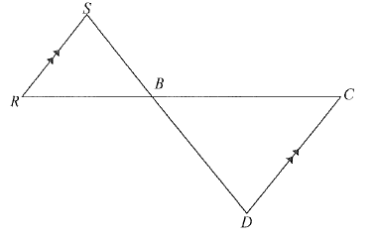
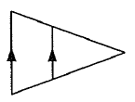
3. 4.

Directions: The two triangles given are similar. Complete the following for each problem:
A. Write the similarity statement.
B. Find x.
C. Find the measure of the indicated side

5.
- $∆LNM$_________________

- x = _________

- LM = ______, QP = ______

6.
- $∆LMK$_________________

- x = _________

- NL = ______, ML = ______

7.
- $∆PQR$_________________

- x = _________

- PS = ______, PR = ______

8.
- $∆EFG$_________________

- x = _________

- EG = ______, HG = ______

