Triangle Similarity 7.3 Notes

**Name ______________________**

**Third Angle Theorem:**

**If two angles of a triangle are congruent to two angles in a second triangle, then both triangles will have congruent 3rd angles as well.**

**Proof:**

**AA Similarity   
If the two angles of one triangle are congruent to two angles of another triangle, then the triangles are similar.**

**Determine whether the following pairs of triangles are similar. Justify your answer.**

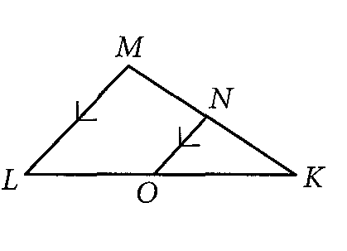

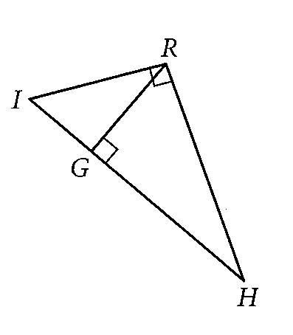

Practice Examples

Identify the Similar triangles, how you know they are similar, find the variable(s) and the measures of the indicated sides.

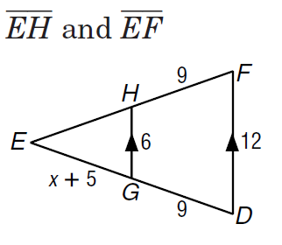**1.**

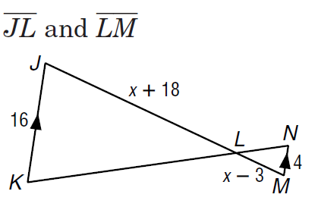

**2.**

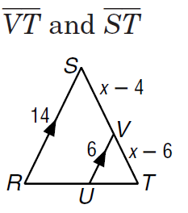**3.**