Name: _________________________________________________ Date: ________________ Hr: _______

**Triangle Review**

Show all work throughout the review to receive full credit!

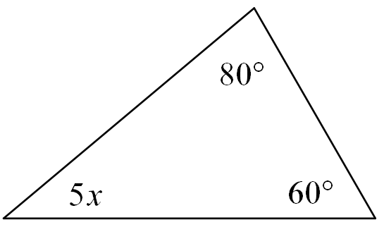**Directions: Find x.**

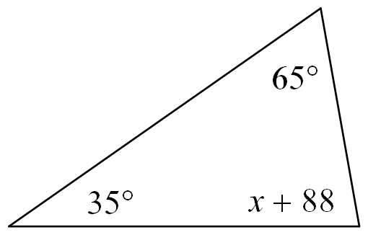1. 2.

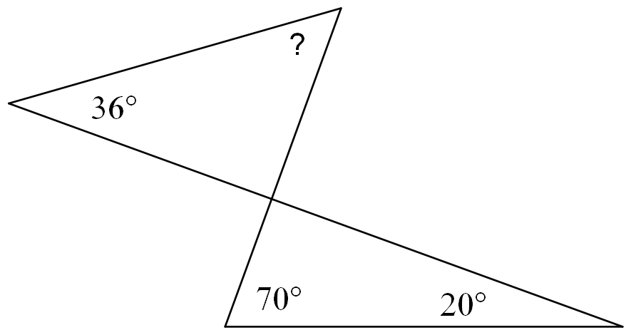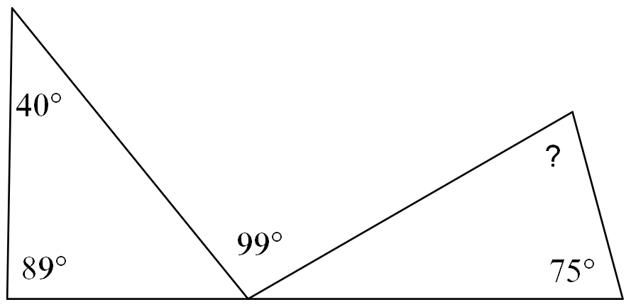3. Find the measure of the missing angle. 4. Find the measure of the missing angle.

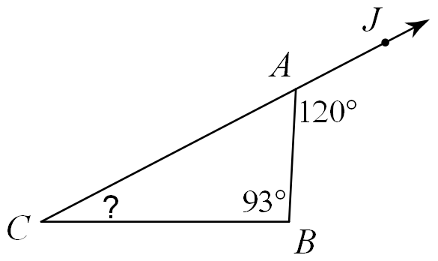5. Find the measure of the missing angle.

**Directions: For 6 and 7, draw, mark and label the figure, solve for the missing variable, and find the lengths of each side.**

6. Find the measure of each side of equilateral $∆RST$ with , , and

7. Find the measure of each side of isosceles $∆ABC$ with $AB≅BC$ if $AB=4y$, $BC=3y+2$, and

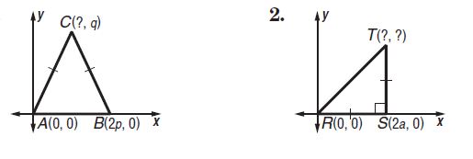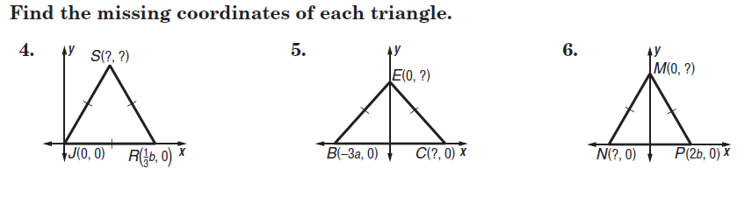8. Find the missing coordinates of each triangle.

Find the measures of the numbered angles.

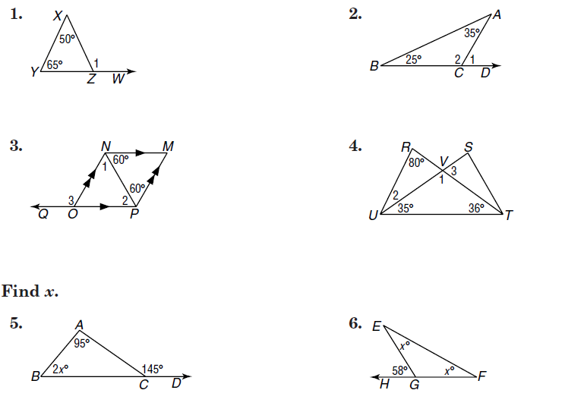9. 10. 11.

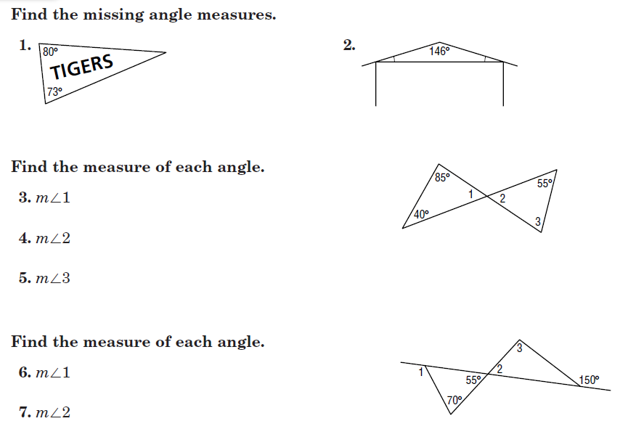



12. 13.

Find all missing angle measures.

14. 15.

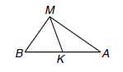16. Given the following triangle with median MK state if the following statements are true or false.

a. $m<MKA = 90ᵒ$

b. $BK ≅ AK$

c. $m<BMK = m<AMK$

d. ∆BMA is isosceles with vertex angle M.

17. Classify the triangle by its sides and angles given the two angle measure are 61 $ᵒ$ and 29ᵒ.

18. Classify the triangle by its sides and angles given the two angle measure are 12 $ᵒ$ and 84ᵒ.

19. If in an isosceles triangle, the vertex angle is 5 more than 3 times the measure of one of the base angles, find the measures of EVERY angle. Show all work and algebraic set up.

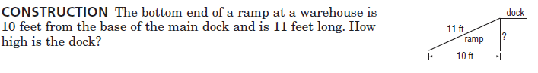

20.

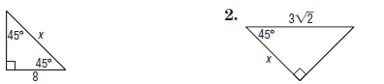21. Find the value of x. 22. Find the value of x. 23. Find the value of x and y.

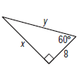

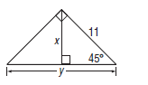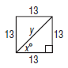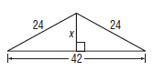24. Find the value of x. 25. Find the value of x and y. 26. Find the value of x and y. and y.

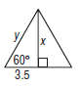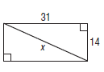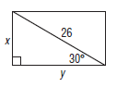27. Find the value of x and y. 28. Find the value of x. 29. Find the value of x and y.

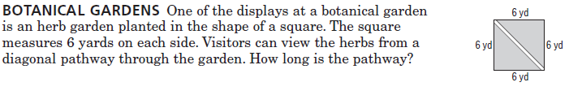30.

31. **MEDIAN** IF LJ is the median of ∆IJK, find x.

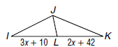

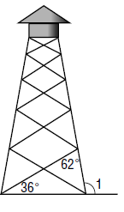32. **TOWERS** A lookout tower sits on a network of struts and posts. Leslie measured 2 angles on the tower, find the measure of <1.

33.. **PATHS** Rachel walks around a triangular path. At each corner, she records the measure of the angle she creates. She makes one complete circuit around the path. What is the sum of the three angle measure that she wrote down during one complete circuit?

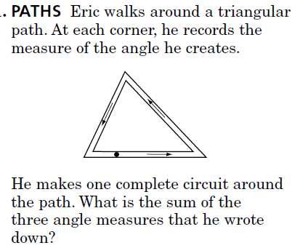

34. **CRAZY ANGLES!** Find the measures of the numbered angles.

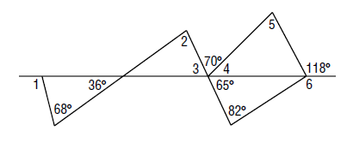

35. **BOOKENDS** Two bookends are shaped like right triangles. The bottom side of each triangle is exactly half as long as the slanted hypotenuse of the triangle. If all the book between the bookends are removed and they are pushed together, they will form a single triangle. Classify the triangle that will be formed as equilateral, isosceles or scalene.

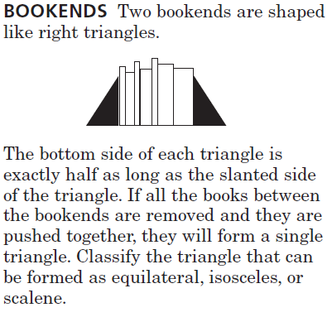

36. Practice for bonus: (a, b, c only)

Find the value(s) that would create an isosceles triangle with vertex at <A. Show all work!

a) $AB={2x}^{2}-5x+4$ and $AC=x^{2}-x+1$

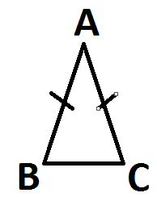

b) $AB={3x}^{2}+4x-2$ and

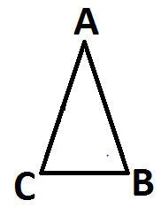

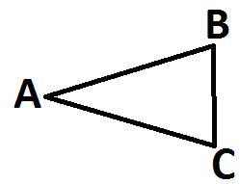c) and

37. Find the measures of the side of ∆KPL and classify the triangle by its sides.

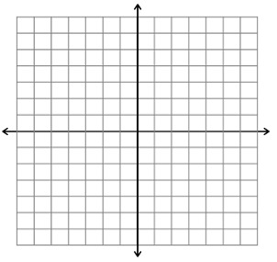K(-4,3), P(1,2), L(-3,-2)

38. Find the measures of the side of ∆ABC and classify the triangle by its sides.

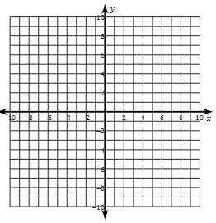A( -9, -7), B(-6, -3), T(-5, -6)

39. Find the measures of the side of ∆RST and classify the triangle by its sides.

R(2,4), S(4,7), T(6,4)

40. If P is the centroid of ∆MNL and QN = 15 feet, find NP and PQ.

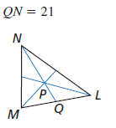

41. If D is the centroid of ∆ABC and ED = 6 inches, find DC and EC.

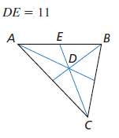

42. 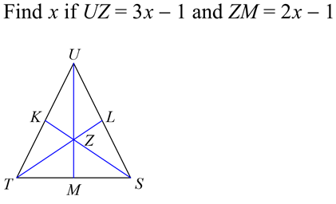

Show all work to receive full credit.

43. Point W is the centroid of $∆QRS$. If $RX=48$, $QW=30$ and $RQ=20$ 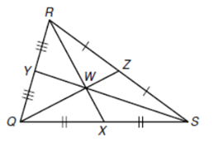, find each length.

a. RW b. WX

**_____________________ ____________________**

c. QZ d. WZ

**____________________ ____________________**

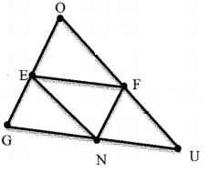e**.** RY

**____________________**

44. Use the $∆GOU,$ where N, E, and F are midpoints of the sides.

a. $\overline{FN}∥ _________$

b. $\overline{OU}∥ _________$

c. If $GU=10$, then EF =________

d. If $NF=8,$ then GO = ________

e. If $UF=7$, then NE = ________

45. In the diagram of $∆ABC,$*D* is the midpoint of AB and *E* is the midpoint of BC.

If $PR=4x-20,$ which expression represents *DE*?

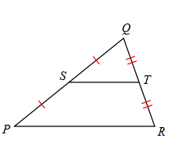

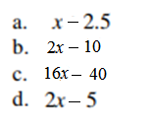 DE =_______________

46. In , find *x*, ZX, and TS.

|  |  |
| --- | --- |
|  | ______________________  ______________________  ______________________ |