Trigonometry Homework #1
In 1 – 4, find the sine, cosine, and tangent of the acute angles of the triangle. (Hint: Use the Pythagorean Theorem to solve for the unlabeled side.)
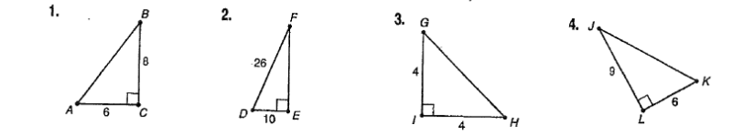

AB=_________ FE= ________ GH= __________ JK=___________
Sin J= ______

Cos J= _____

Tan K= _____
Sin H= ______

Cos G= _____

Tan G= _____
Sin F= ______

Cos F= _____

Tan F= _____
Sin A= ______

Cos A= _____

Tan A= _____

In 5 – 8, find the length of the labeled sides (the missing variables).
5. 6. 7. 8.

9. A train is traveling up a slight grade with an angle of inclination of only 2$°$. After traveling 1 mile, what is the vertical change in feet?

In 10 & 11, use the figure of the lighthouse.
10. At 2 p.m., the shadow of a lighthouse is 22 feet long and the angle of elevation
is 72$°$. Find the height of the lighthouse.

11. At 6 p.m., the angle of elevation (bottom angle in image) of the sun is 40$°$.
Find the length of the shadow cast by the lighthouse.

