Name: ________________________________ Hour: ____ Unit Circle Wksht 30-60-90

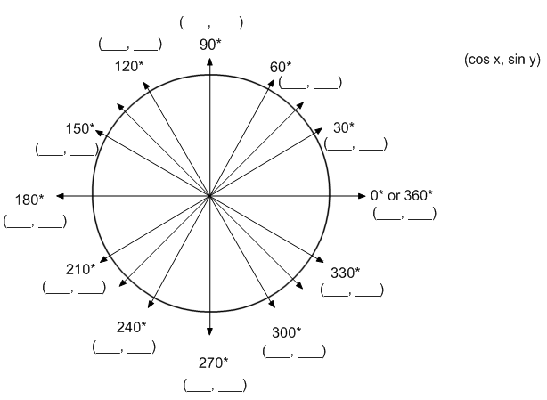
Complete ALL OF THE COORDIANTES of the unit Circle with all 30, 60, 90 measurements.

Fill in the exact measurements (no decimals!) for the following.

1. sin (30°) 2. tan (30°) 3. cos (120°)

4. tan (90°) 5. cos (30°) 6. tan (180°)

7. tan (300°) 8. tan(210°) 9. cos (150°)

10. sin (330°) 11. sin (60°) 12. sin (240°)

13. cos (270°) 14. sin (360°) 15. tan (330°)
Name: ________________________________ Hour: ____ Unit Circle Wksht 45-45-90

Complete ALL OF THE COORDIANTES of the unit Circle with all 45, 45, 90 measurements.
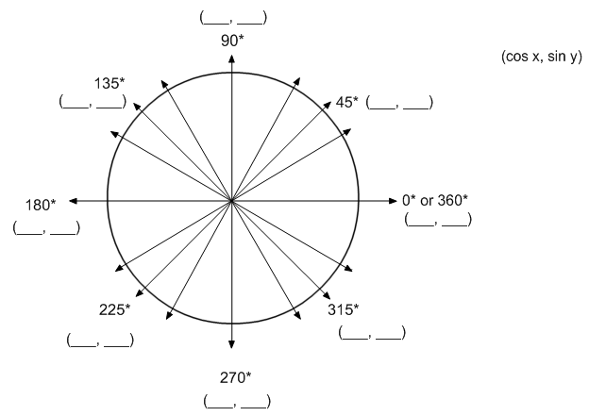

Fill in the exact measurements (no decimals!) for the following.

1. sin (180°) 2. tan (45°) 3. cos (45°)

4. tan (315°) 5. cos (135°) 6. tan (360°)

7. tan (90°) 8. tan (180°) 9. cos (270°)

10. sin (90°) 11. sin (225°) 12. sin (360°)

13. cos (360°) 14. sin (135°) 15. tan (270°)

