Name: ____________________________________________
UNIT CIRCLE and Exact Values HW

Directions: Without using a completed Unit Circle, fill out the radians and points which lie on the Unit Circle given the degrees below.
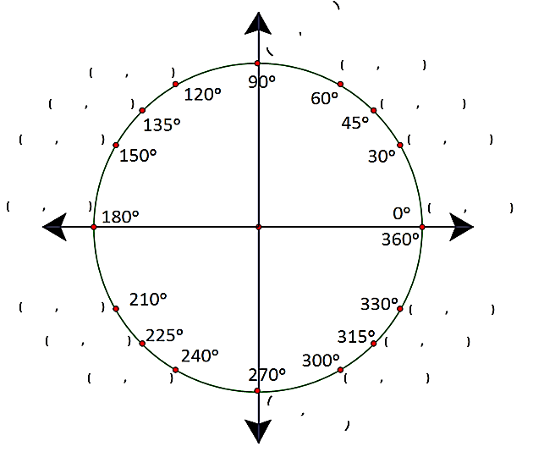

Directions: Use your unit circle to find the exact values of each expression below. Show what coordinate you used for the each question. This will be considered as your work for each question.
1. cos $\frac{π}{2}$ 2. sin $\frac{7π}{6}$ 3. cos $\frac{4π}{3}$

4. tan $\frac{7π}{4}$ 5. sin $\frac{3π}{2}$ 6. tan $\frac{7π}{6}$

7. tan 2$π$ 8. cos$π$ 9. sin $\frac{11π}{6}$

10. $\tan{2π}$ 11. $\tan{\frac{π}{3}}$ 12. $\tan{\frac{π}{2}}$

13. sin 45ᵒ 14. cos 150ᵒ 15. tan240ᵒ

16. tan 315ᵒ 17. sin 270ᵒ 18. cos 210ᵒ

19. tan 0ᵒ 20. cos 180ᵒ 21. sin 330ᵒ

22. $\tan{120°}$ 23. $\tan{135°}$ 24. $\tan{240°}$

25. If $sinθ=-\frac{\sqrt{3}}{2}$ and $θ=\frac{bπ}{3}$ on the unit circle, give at least one possible value for b.

