Name: ________________________________________________________________ Date: _______ Hr: ____

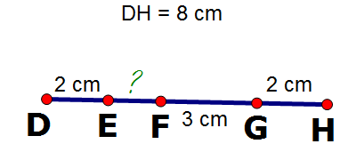
Unit One Spiral- The Basics- Geometry

Use the segment below to find the measures of the segments.
You do not need to justify.

1. EF= _______2. FH= _______3. HE= _______4. DG= _______

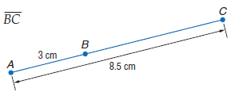
5. $\overline{EG}$ 6.
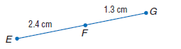

For each problem, you must complete on a lined sheet of paper: Write the question for each and then a) Sketch a diagram, b) Write a geometry equation for the diagram along with the justification (highlight this for each problem!), c) Substitute the algebra, d) Solve, e) Justify each step. F.) Check to make sure your answer makes sense. Failure to follow these directions, complete work, or bring work to class will result in an zero.

7. C is between R and T. Find RT if RC = 2x + 7, CT = 28, and RT = 4x.
8. B is the midpoint of segment AC. AB = 5x and BC = 3x + 4. Find AB, BC, and AC.
9. N is between M and R. MN = 2.5x, NR = x, and MR = 5x – 3. Find the length of each segment.
10. Y is between X and Z. XY = 5a + 3, XZ = 72, YZ = 8a – 9. Is Y the midpoint of XZ?
11. N is between A and X. AN = x + 1, NX = x², and AX = 21. Find x and the length of each segment.
12. A is between B and C. BA = x², AC = 6x + 10, and BC = 17. Find x and the length of each segment.
13. Points A, B, and E are collinear. BE = 20, AB = 8, and AE = 12. Which point is between the other two?
14. Point M is the midpoint of segment AB. AM = 3x + 40 and MB = x². Find x and AB.
15. B is between H and F. HB =²/₅x and BF = 2x – 12. If HF = 180, find x.
16. WY bisects UV at Y. If UY = 2x + 1 and YV = X + 7, find UY and UV.
17. B is between A and C, and C is between B and D. AC = 2x, BD = x, AD = 27, and BC = 3. Find BD.
18. L is between K and M. KL = x² – 10, LM = 5x + 4, and KM = 2x² – 42. Find x.

Yes, your work must be shown on separate lined sheet of paper. If you do not bring your sheet, or you “leave it at home” it will still be a zero. DO NOT lose the work.
21.
20.
19.

24.
23.
22.

