Using a Protractor Notes
Review Directions – Use the figure below for the following.

Directions- Classify each angle as right, acute or obtuse, and then measure the angle with a protractor. Don’t forget your units as degrees!

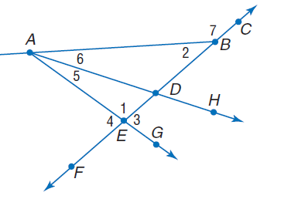
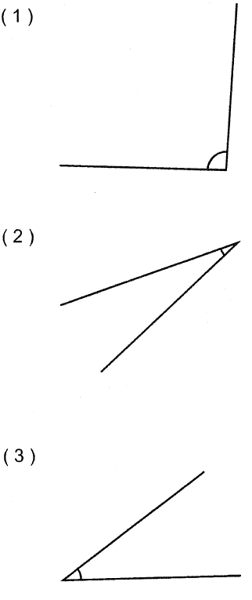

Name the vertex of each angle.
6. <1 7. <2

8. <6 9. <5
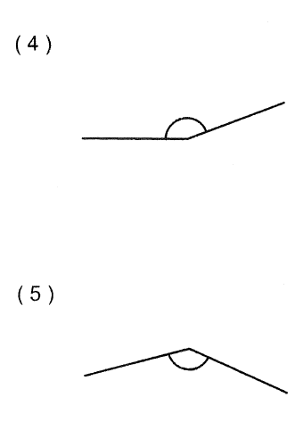

Write another way to name each angle.
10. <7 11. <AEF

12. Name a point in the interior of <GAB.

13. Name an angle with vertex B which
appears to be acute.

