Using a Protractor- The Basics
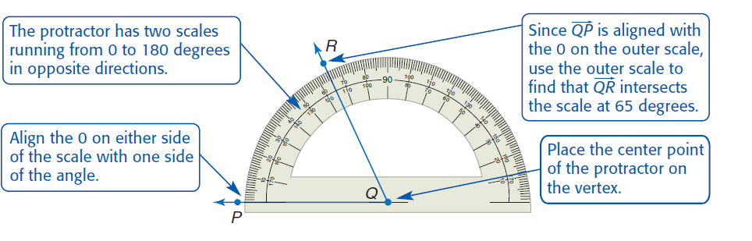

Directions- Classify each angle as right, acute or obtuse. Then measure the angle with a protractor. Don’t forget your units as degrees!
