Name: _______________________ Hr: _______
Vector Practice
Find the component form, magnitude and direction for $\overset{⃑}{MN}$.
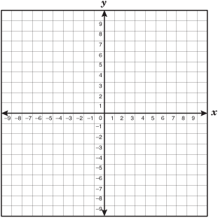
1. M(8, 1) and N(2,5)
Component Form:

Magnitude:

Direction:

2. M(-1 ,7) and N(6, -8)
Component Form:

Magnitude:

Direction:

3. Find the magnitude and the direction of $\overset{⃑}{v}=<12,-9>$
Magnitude: Direction:

4. Graph ∆ABC with vertices A(2,-1), B(-7,-2) and C(-2,8) under the translation $\overset{⃑}{v}=<-1,-4>$. This means:

5. Graph ∆XYZ with vertices X(2,5), Y(1,1) and Z(5,1) under the translation $\overset{⃑}{v}=<2,3>$. This means:

