**Trigonometric Transformations Name___________________________**

**Supp Alg 14. 2 Vertical Shifts and Midlines Date_______________**

**1. Sketch the graphs of ${y=sinθ{+1, y=\sin{θ-1}}}$**  **using different colors and label the graph with the equation.**



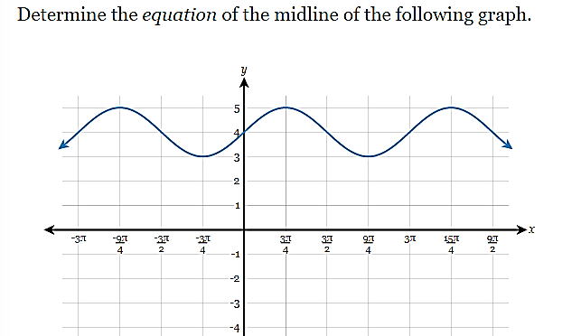**Example 1: Example 2:**

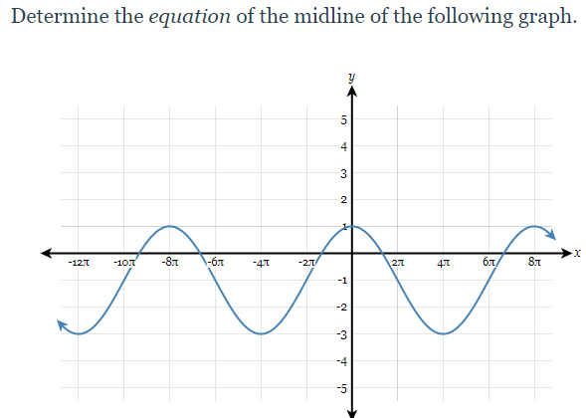

**Example 3:** Graph the equation $y=cosθ+3$