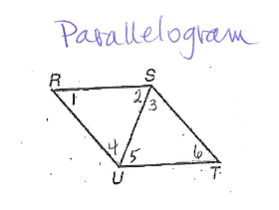
What Is The Angle Measure?
Parallelogram
Given that m<1 = 15 and m<3 = 85 for the parallelogram, find the following angles:
m<2 = _____________ m<4 = ________________
m<5 = _____________ m<6 = ________________

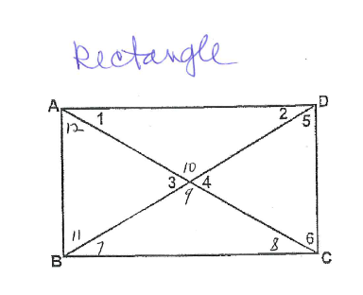
Rectangle

Given that m<1 = 20 and m<4 = 40 for the rectangle, find the following angles:
m<2 = _________ m<3 = ____________
m<5 = _________ m<6 = ____________
m<7 = _________ m<8 = ____________
m<9 = _________ m<10 = ___________
m<11 = _________
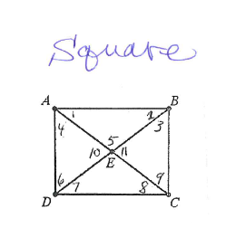
Given that the shape is a square, find the following angles:
Square
m<1 = ______________
m<2 = _______________ m<3 = __________________
m<4 = _______________ m<5 = __________________
m<6 = _______________ m<7 = __________________
m<8 = _______________ m<9 = __________________
m<10 = ______________ m<11 = _________________
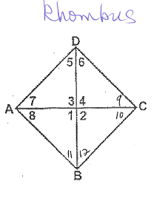
Given the m<9 = 30 for the rhombus, find the following angles:
Rhombus
m<1 = ____________ m<2 = ________________
m<3 = ____________ m<4 = ________________
m<5 = ____________ m<6 = ________________
m<7 = ____________ m<8 = ________________
m<10 = ___________ m<11 = _______________
m<12 = ___________

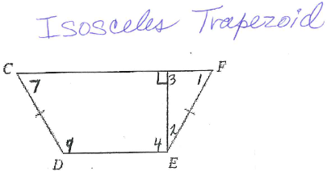
Isosceles Trapezoid
Given m<7 = 53 for the isosceles trapezoid, find the following angle measures:
m<1 = ____________
m<2 = ____________
m<3 = ____________
m<4 = ____________
m<9 = ____________

