Name: _________________________________________________________________
ACC Geometry: What Lines Are Parallel Worksheet
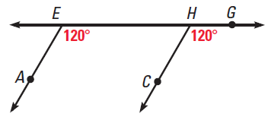
Directions: Given the information, determine which lines, if any are parallel. State how you know by justifying.
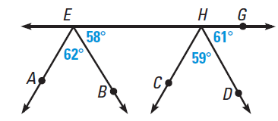
1. 2.

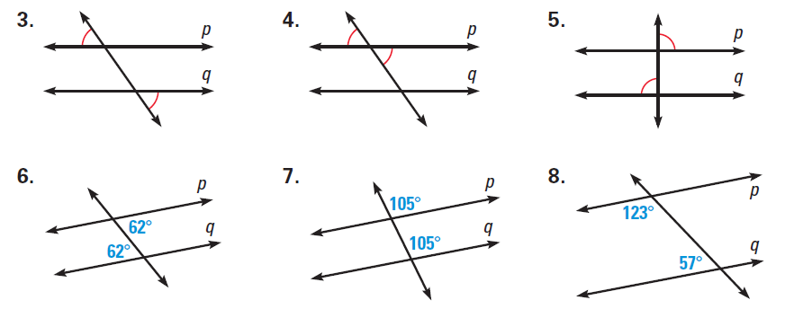

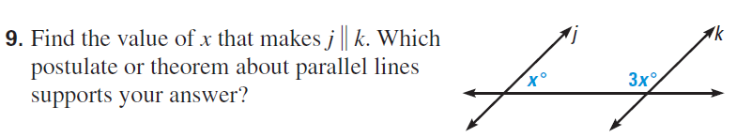

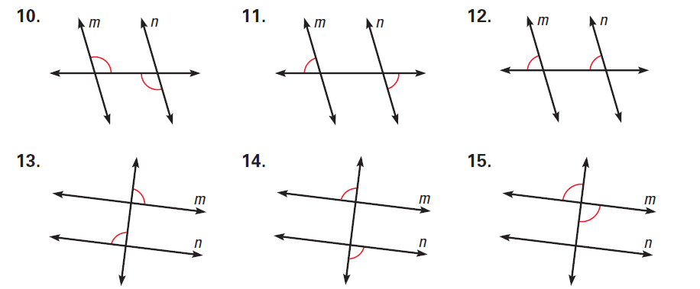

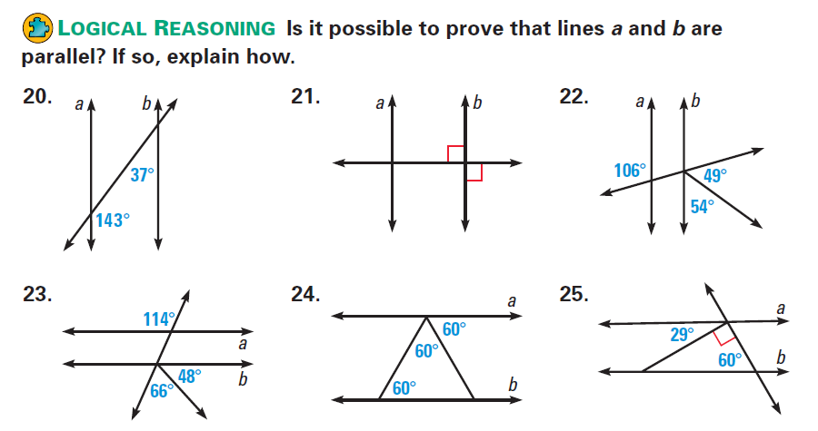

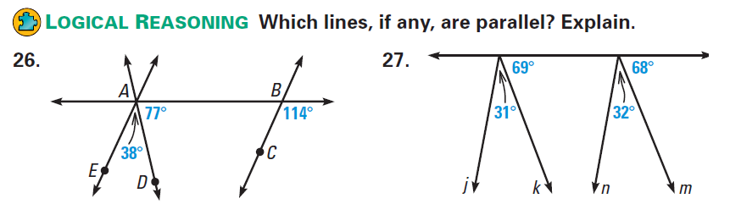

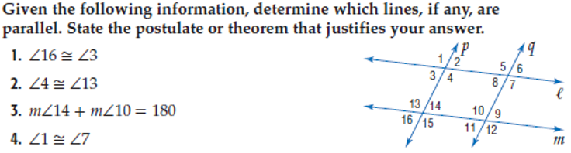
From textbook:

