Notes/Examples
Working Backwards: Surface Area & Volume of
Cylinders, Cones, and Spheres

1. Given the cylinder below, 2. The volume of a cylinder is 54$π$ ft³ and
find the height. V = 11083.5 ft³ the height is 3 ft. Find the diameter of the
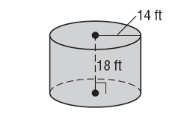
Cylinder.

3. A cone has a radius of 6m and a surface area of 66π m². Find the slant height of the cone.

4. The cone below has a volume of 242π m³. Find the height.
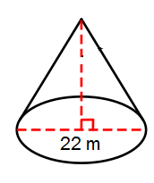

5. A sphere has a SA of 676$π$ cm², find the radius.

6. A sphere has a volume of 4500$π$m³, find the radius.

7. A sphere has a volume of 7776$π$in³, find the diameter.

