Name: __________________________________________________________________________
ACC 10.1-10.4 Spiral Assignment

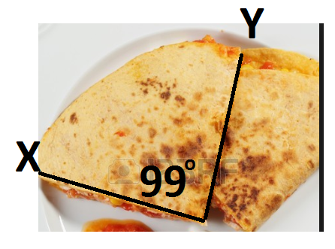
1. The figure represents a quesadilla with a diameter of 14inches. Find the exact arc length of $\hat{XY}$.

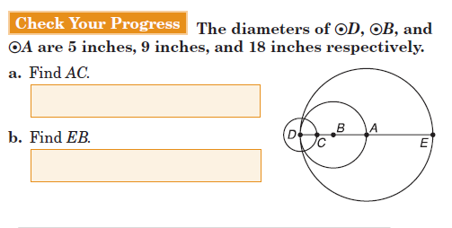
2.

3. Find the exact circumference of circle K.
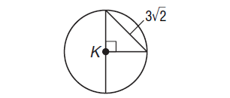

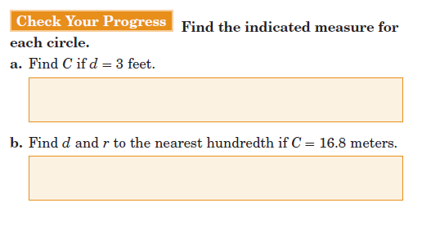

4. * Use exact values for a and round to the nearest tenth for b.

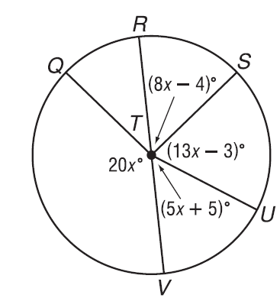
5. Find the measures of:

a.) <RTS b.) <STV

c.) $m\hat{QV}$ d.) $m\hat{SVQ}$

6.
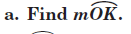

7.

8.

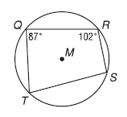
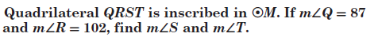
9.

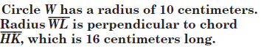
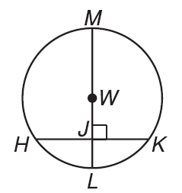
10.

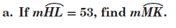

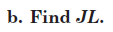

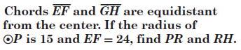
11.

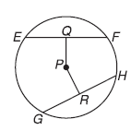

12. Find the radius of a circle if a 28 foot chord is 6 feet from the center of the circle. Find the exact value and then round to the nearest hundredth.

13. In circle K, JG is 30 inches. Find the distance of KL, round to the nearest hundredth. Then find $m\hat{GJ}.$
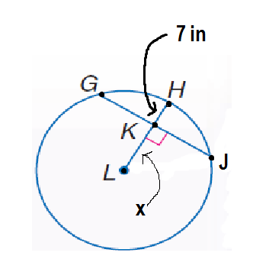

14. Find the exact value of JG.
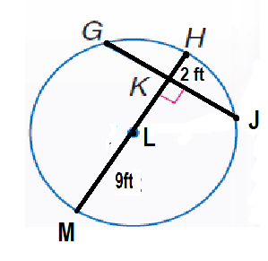

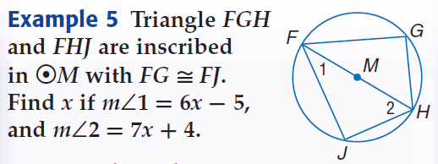
15.

16. Find the exact value of the radius for circle C if chord AB is 18 meters and AB bisects
radius CD.

17. If the length of an arc with the measure of 120ᵒ is 14π, find the radius and diameter of the circle.

