Name: __________________________________________________________________________
Geometry Extra Review (10.3-10.4) Notes
1. In circle M, $∠JKL$ is an inscribed 2. The measure of $∠$GOE is 74º
angle whose intercepted arc JL measures $66°$. What is the measure of $∠$GFE?
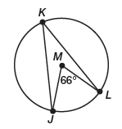
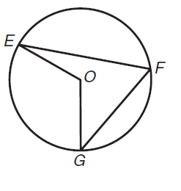

3. The measure of $∠$WCY= 83ᵒ 4. Find the arc LENGTH of arc AB.
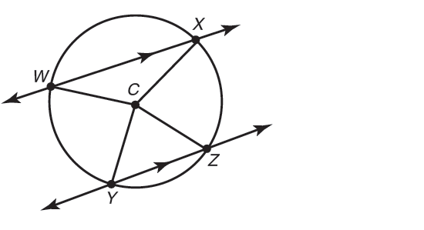
What is <XCZ?

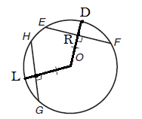
5. The radius of circle O is 7ft and OR=5ft. (a) Find ER. (b) Find HG. (c) Find $m\hat{HL}$.

6. 7. Find the radius of a circle if a 30 foot chord is 10 feet from the center of the circle. Round to the nearest hundredth.

7. Circle W has a radius of 13cm. Radius WL is perpendicular to chord HK.
HK is 18cm. (a) Find WJ. (b) Find JL.
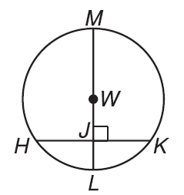

\

8. Find x and find y.

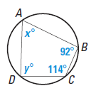

Name: __________________________________________________________________________
Geometry Extra Review (10.3-10.4) Practice
1.Determine the measure of each minor arc. 2. Determine the measure of each central or inscribed angle.
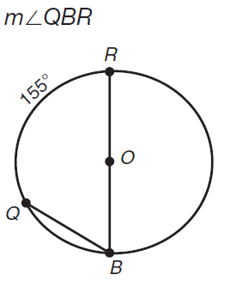
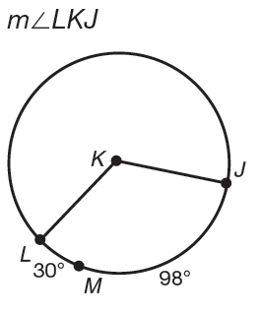
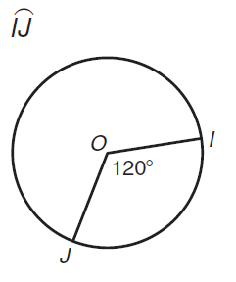
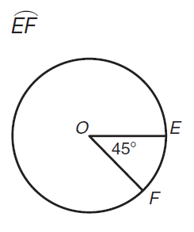
a. b. a. b.

3. The figure represents a quesadilla with a diameter of 14inches. Find the exact arc length of $\hat{XY}$.
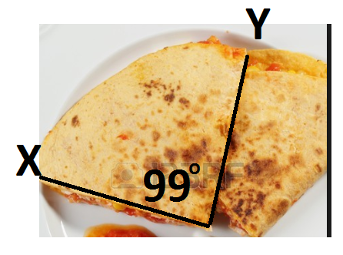

4.

5.

6. Quadrilateral QRST. Find <S and <T. 7. Find x and y.
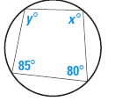
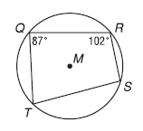

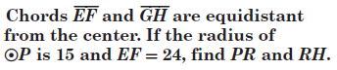
8.

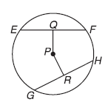

9. Find the radius of a circle if a 28 foot chord is 6 feet from the center of the circle. Find the exact value and then round to the nearest hundredth.

10. Find the value of JG. if KL=9ft.
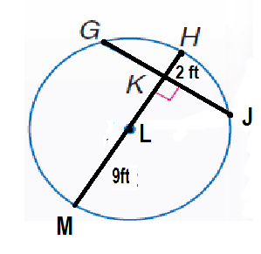

11.

12.

13. The measure of <AOB= 62ᵒ. 14. The measure of <COD=98ᵒ.
What is the measure of <ACB? What is the measure of <CED?

15. The measure of <EOG=128ᵒ. 16. The measure of <EGF=28ᵒ.
What is the measure of <EFG? What is the measure of <EOF?

17. The measure of$\hat{ TS}=94$ᵒ and $\hat{ QR}=98$ᵒ. 18. The measure of$\hat{ LM}=50$ᵒ and $\hat{ KN}=120$ᵒ.
What is the measure of <TUS? What is the measure of <LPM?

