Name: ____________________________________________________ Date: ________

**WOW!!! What a great review for your test!!** Only thing left to learn is 13.6!!

**C:\Documents and Settings\kschmidt\Local Settings\Temporary Internet Files\Content.IE5\6Y88J8A7\MC900390996[1].wmfAccelerated Geometry 13.1-13.3**

**13.1 Right Triangle Trigonometry**

Find the following 6 trigonometric values for the following triangle.

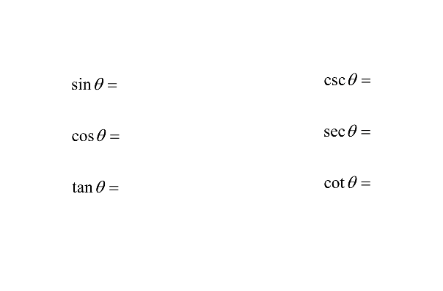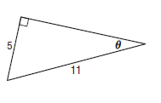

**13.2 Angles and Angle Measures**

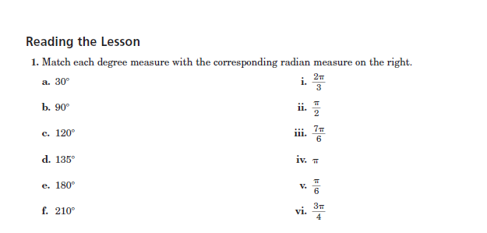

(a.) Draw the angle with the given measure in standard position, (b) find ’ as the reference angle and (c) find one positive and one negative conterminal angle with the given angles.

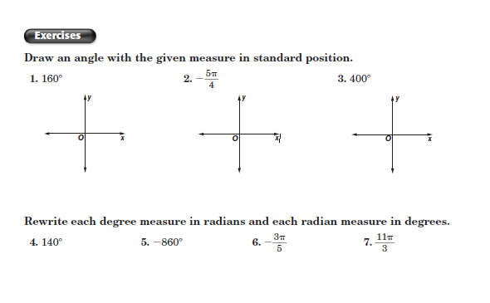

2. 3. 4. 5.



**13-3 Trigonometric Functions of General Angles**

**Show all work on separate paper.**

