Acc Geometry Name___________________________
4.6 Isosceles & Equilateral Proof Practice Date_______________

Isosceles Triangle Theorems
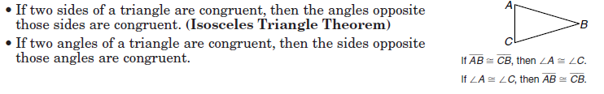
Equilateral Triangle Theorems
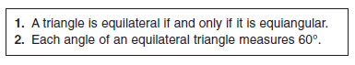

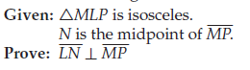
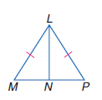

4.6 Review of Basics

1. m<CFD 2. m<AFB 3. m<ABF 4. m<A

5. Find x. 6.
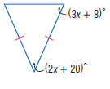

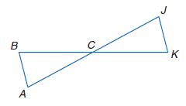
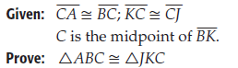
7.

