5-1 Skills Practice and Practice
(out of work book)
Bisectors, Medians and Altitudes (OH MY!)
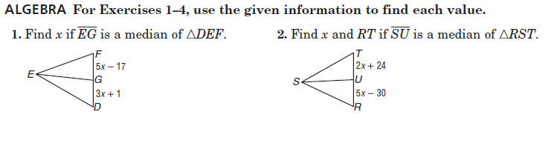

5. Find x. 6. Find y. 7. Find z.

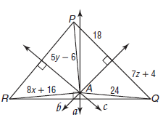

8. Find x. 9. Find y. 10. Find z.

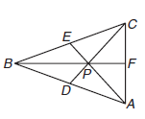
5-1 Practice (out of work book)
Bisectors, Medians and Altitudes (OH MY!)

For #5-6

For #s 7-9

