Name: ____________________________________________________________ Date: ____________

8.1-8.6 Intervention Acc Geometry

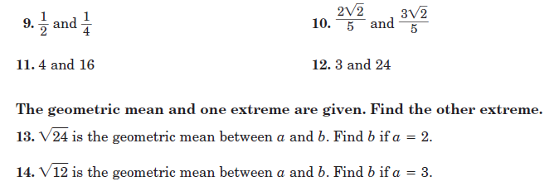Find the geometric mean between the two numbers.

1.

2.





3.

4.

**Use EXACT values for #5-18 and round to the nearest tenth for #19-24 to find EACH variable.**

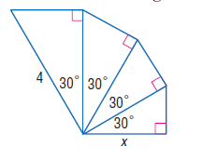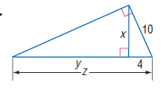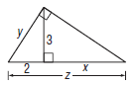

5. 6. 7.

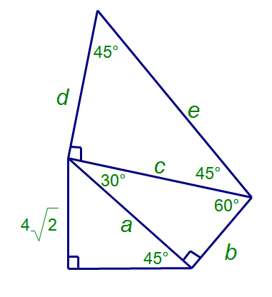

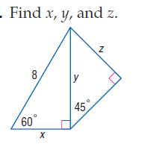

8. 9. 10.

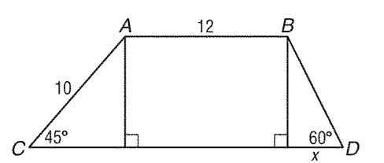

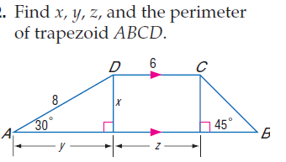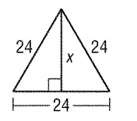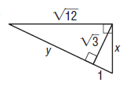11. 12. 13.

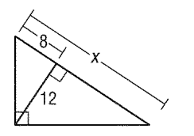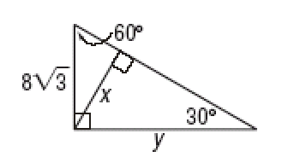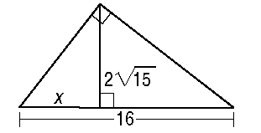

14. 15. 16.

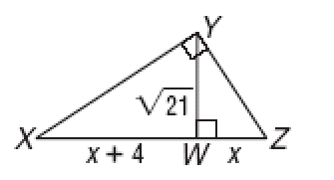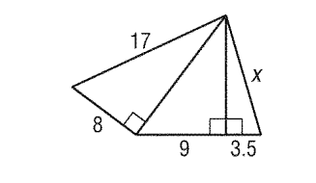

17. 18.

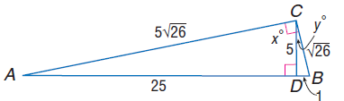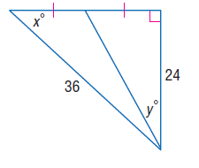19. 20.

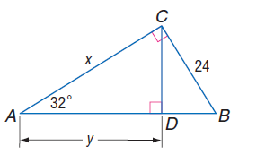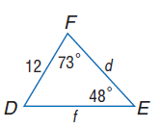

21. 22.

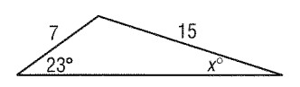

23.

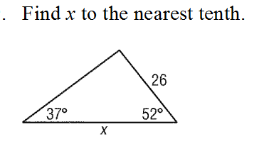

24.

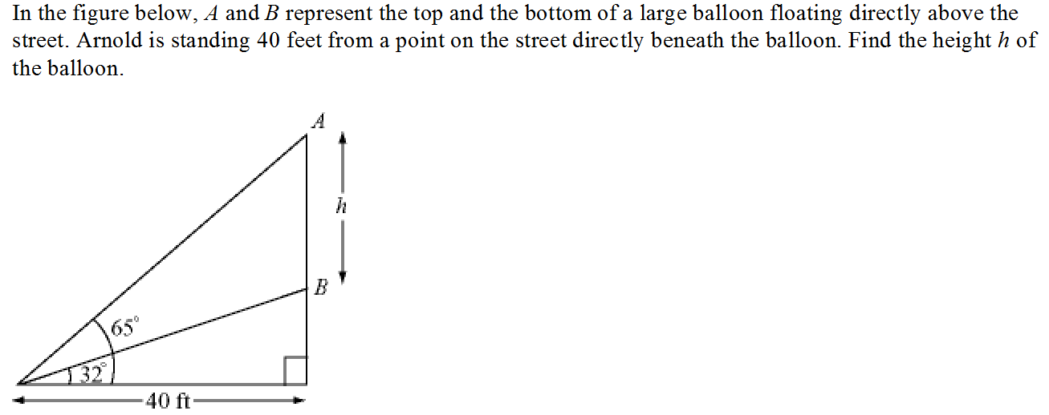25.

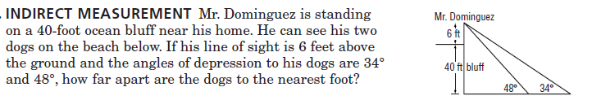

26.

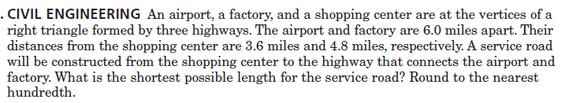

27.

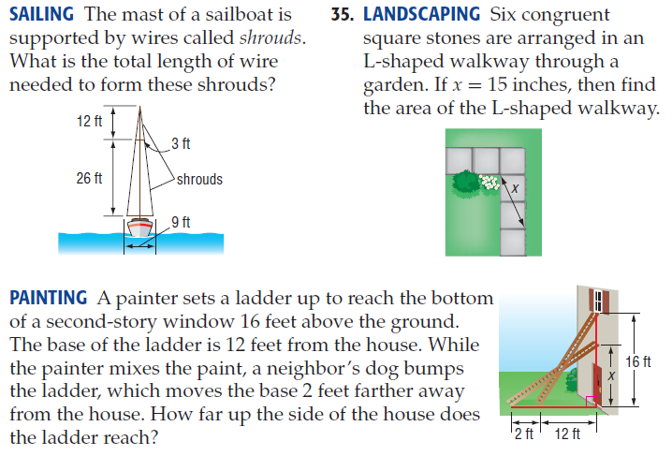28. 29.



30.

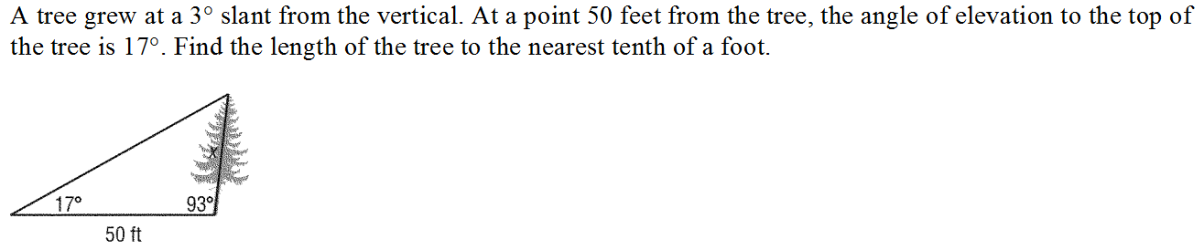

31.