Acc Geometry
Surface Area of Prisms- Notes

Prior to lesson:
Pages: 5-8 Cut out and find the area
http://www.misd.net/mathematics/ImplementingGeometryUnits/3Dimensional/Netspyramidsandprisms.pdf
Put all work on the work sheet:
http://www.misd.net/mathematics/ImplementingGeometryUnits/3Dimensional/Prisms.pdf
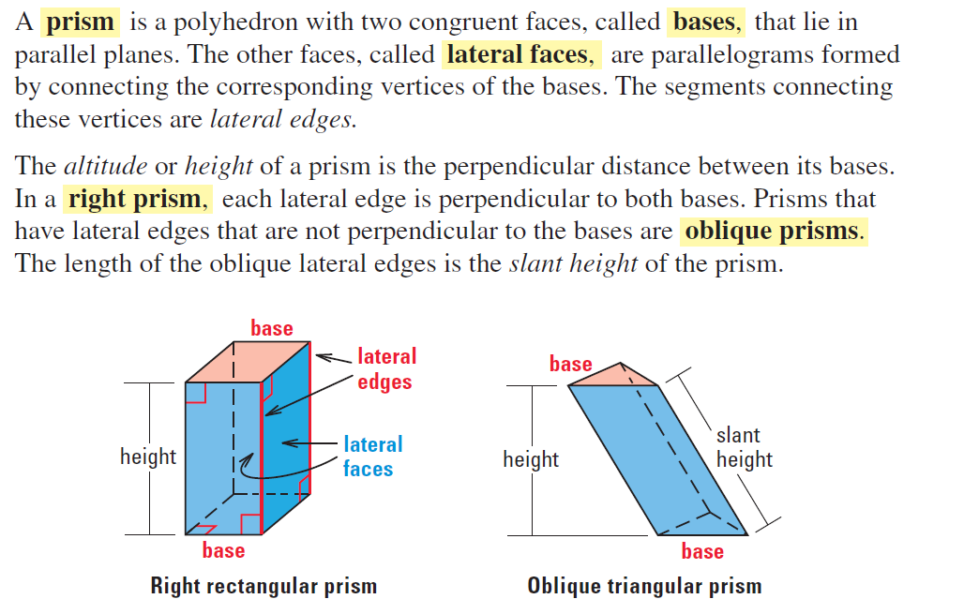

Example1:
Find the lateral area and surface area of the prism.

Find the lateral area and the surface area of the following solids. Round your answers to the nearest hundredth.
Example 2:
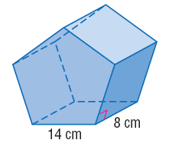

Example 3:
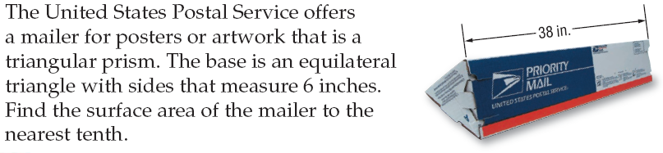

Name: __________________________________________________________________________ Date: ___________
Acc Geometry
Surface Area of Prisms- HW

Directions: Round your answers to the nearest tenth if necessary.

Use 6x7 as the bases.

3. 4.

5.

6. 7.

8. 9.

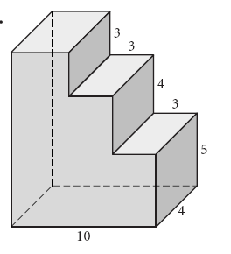
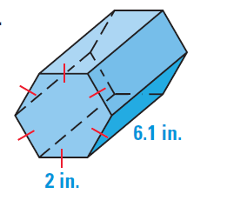

10. 11.

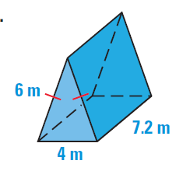

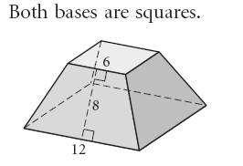
12. 13.

14. The base is a regular hexagon with a=12.1cm s=14 cm and h=7cm

15.

16.

17. 18.

Name: __________________________________________________________________________ Date: ___________
Real World Applications
Round answers to the nearest tenth.
1.

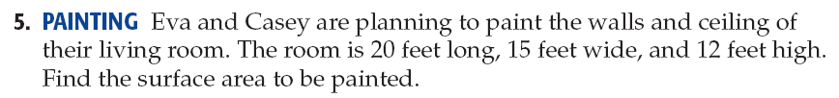
2.

For #3 & 4 use the following information:

3.

4.

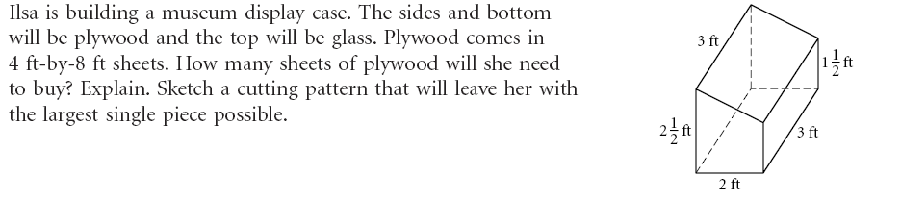
5.

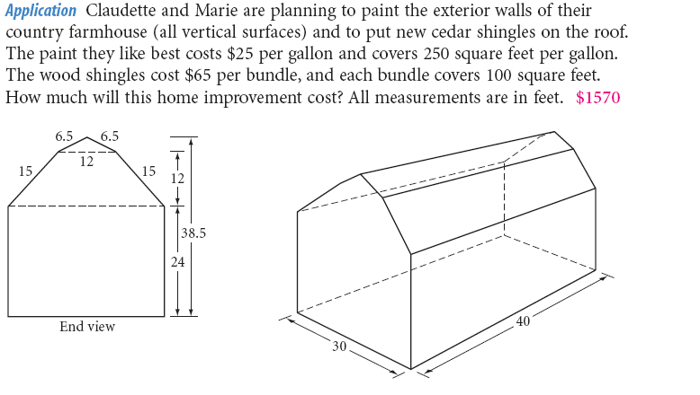
6.

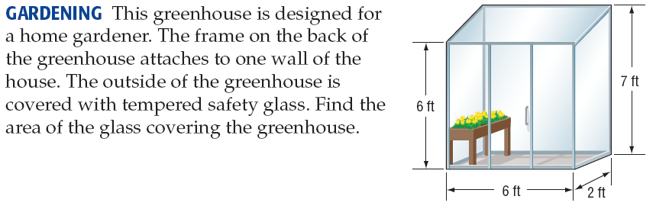
7.

Solutions: SA of Prisms HW
1. 840 in² 2. 234 cm² 3. 128 in² 4. 162 yd² 5. 216 in² 6. 850 m²
7. 336 ft² 8. 415.2 km² 9. 454.0 mi² 10. 356 cm² 11. 94.0 in² 12. 468 cm²
13. 137.8 m² 14. 1604.4 cm² 15. 1600cm² 16. 352 ft² 17. 606.5 in² 18. 2824.8 cm²

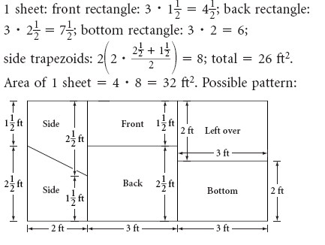
Real World Applications
1. 24 ft² 2. 1140 ft²
3. No, walls are 600ft2; 1.5 gallons will only be 5.
enough for one coat.
4. $80
6. $1570
7. 75.4 ft²

