Acc Geometry
Surface Area of Pyramids- Notes

Prior to lesson:
Pages: 1-4 Cut out and find the area
http://www.misd.net/mathematics/ImplementingGeometryUnits/3Dimensional/Netspyramidsandprisms.pdf
Put all work on the work sheet:
http://www.misd.net/mathematics/ImplementingGeometryUnits/3Dimensional/pyramids.pdf
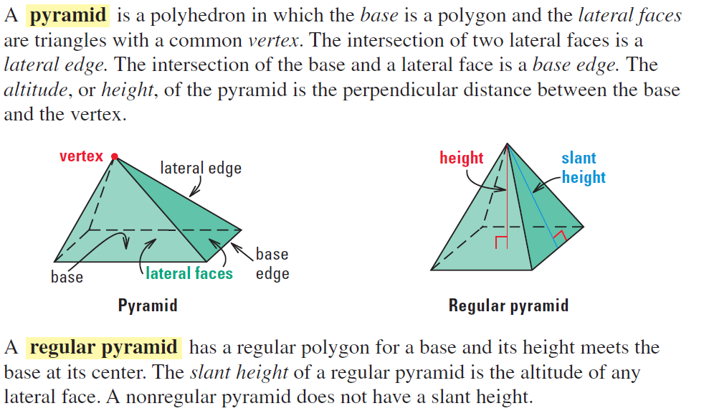

Write the expression for the lateral area and surface area of the regular pyramid.
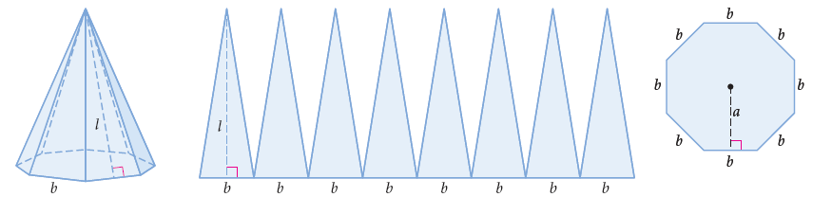

Find the lateral area and surface area of each solid. Round to the nearest tenth if necessary.
Example 1:

Example 2:

Example 3: Example 4:

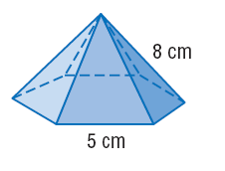
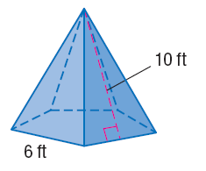

Example 5:
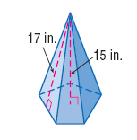

Name: ______________________________________________________ Date: __________
Surface Area of Pyramids- HW
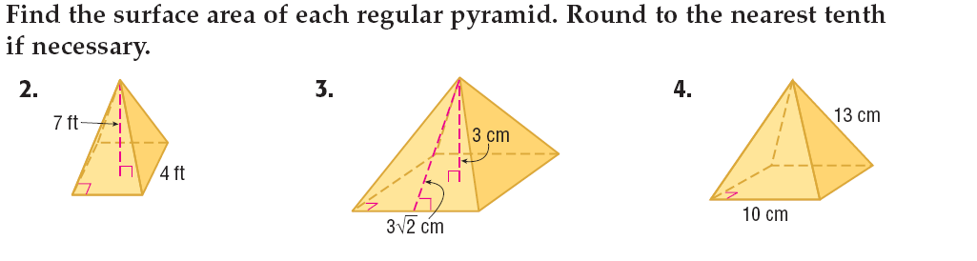

Real World Problem Solving
1.

2.

3.

4.

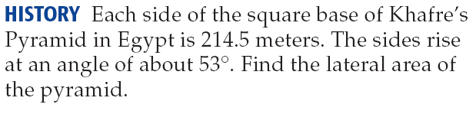
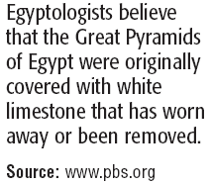
7.

8.

A) Find the height.

B) Find the lateral area.

C) Find the surface area.

D) Which has the greater lateral area: pyramid of the cube? Explain.

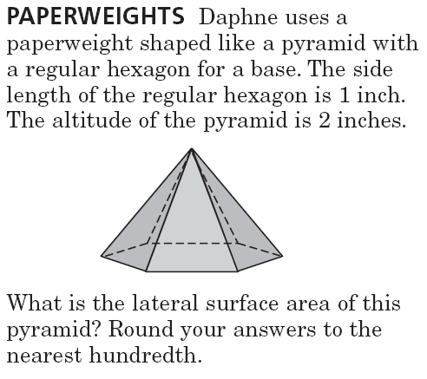
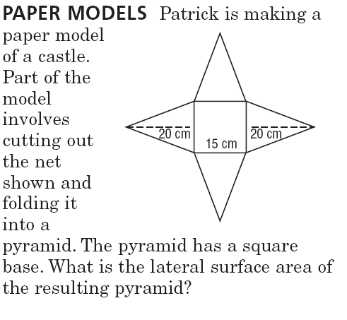
9. 10.

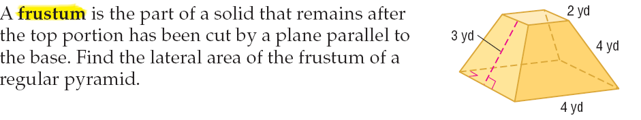
11.

12.

Solutions: 2. 74.2 ft² 3. 86.9 cm² 4. 340cm² 5. 119 cm² 6. 133.6 in² 7. 147.7 ft²8. 421.5 cm² 9. 173.2 yd² 10. 86.1 m² 11. 326.9 in² 12. 157.6 cm² 13. 27.7 ft²
Real World Problem Solving:
1. 1040 cm² 2. 1549.2 ft² 3. 2.3in on each side 4. 527,237 ft² 5. 4.98 in² 6. 41.64 in²7. 76,452.5 m² 8. A)20ft b)816ft² c) 960ft² d) The LA of pyramid is 240 ft², LA cube= 576ft². The base of each triangular face of the pyramid is the same length as the square and the height is less than that of the square. Therefore, each square face has a greater area than each triangular face.
9. 600 cm² 10 6.54 in² 11. 36 yd² 12. 144in²

