Name: ___________________________________________________ Date: _______________Hour:_______
Advanced Area Application Group Work A

Complete the following- showing all work in a labled manner. You should write out complete words and indicate what section (a-m) you are working on at the time.

Mrs. Faehner will be rennovating her home this summer.
She is having a pest control problem so she is having a bug zapper placed along the perimeter of her home. The materials for the bug zapper costs $15 for each 2 foot section. It is only sold by two foot sections so you cannot buy a portion of the material.

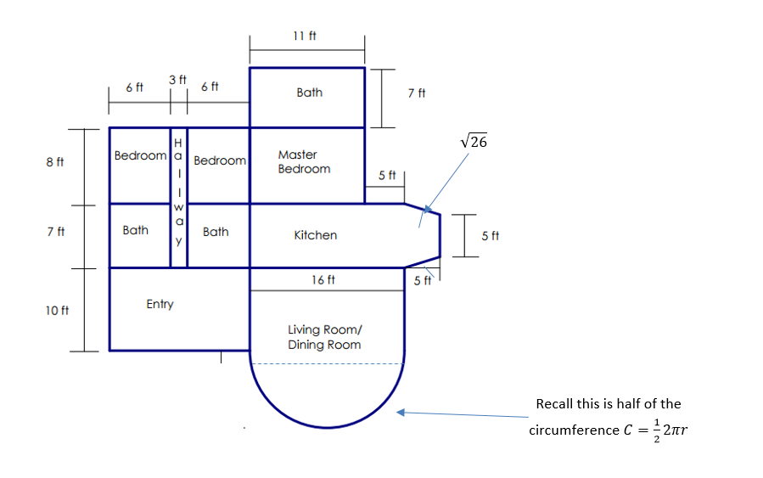

Name: ____________________________________________________________________________________
Advanced Area Application Group Work A
Complete the following- showing all work in a labled manner.

(a) How many sections of the bug zapping material will she need?

(b) How much will the bug zapper cost before taxes?

She will be tiling the areas labeled bath, kitchen and entry. The tiles are 1 square foot and cost $1.05 each. Again, she will need to round up to find the total number of tiles she needs because they are only sold in square foot sections.
(c) How many tiles will she need?

(d) How much will the tiles cost before taxes?

She is planning on putting wood floors in her master bedroom and hallway. The wood flooring costs $10 per square foot and should be rounded up to the nearest foot- to assure the whole area is covered in wood.
(e) What is the rounded square footage (to the nearest foot) of wood needed for this progect?

(f) How much will the wood cost BEFORE taxes?

She is planning on carpenting the living/dining room and the two bedrooms. The carpeting she is planning on using costs $25.08 per SQUARE YARD with free delivery and instalation.
(g) What is the total square footage (round to the nearest tenth) needed of carpet?

(h) Convert the carpet order to square yards.

(i) How much will the carpeting project cost before taxes?

Mrs. Faehner has $7,000 to rennovate her home this summer.
(j) How much will the total cost of the rennovations be (including the bug zapper), before taxes?

(k) How much will the taxes alone cost?

(l) What is the total cost (including tax) of her project?

(m) Will Mrs. Faehner have enough money to complete the renovation?

