Name: ________________________________________Date: ____________HR: ___________

*Advanced Review: Quadrilateral Practice*

**True or False with Counter Examples**

**For Exercises 1 - 10, identify each statement as true or false. For each false statement, sketch a**

**counterexample or explain why it is false.**

1. The diagonals of a parallelogram are congruent.

2. The consecutive angles of a rectangle are congruent and supplementary.

3. The diagonals of a rectangle bisect each other.

4. The diagonals of a rectangle bisect the angles.

5. The diagonals of a square are perpendicular bisectors of each other.

6. Every rhombus is a square.

7. Every square is a rectangle.

8. A diagonal divides a square into two isosceles right triangles.

9. Opposite angles in a parallelogram are always congruent.

10. Consecutive angles in a parallelogram are always congruent

**Identifying Properties: In problems 1-8 below, list the letters of the quarilaterals that the properties hold true for: a) Parallelogram b) Rectangle c) Rhombus d) Square**

1. Diagonals bisect each other. 2. All <’s are right <’s

3. All sides are congruent. 4. Opposite sides are congruent.

5. Opposite angles are congruent. 6. Diagonals are congruent.

7. Diagonals are perpendicular. 8. Opposite sides are parallel.

**Applying Properties:**

Solve for x and write the justification for the set up for the parallelograms below.

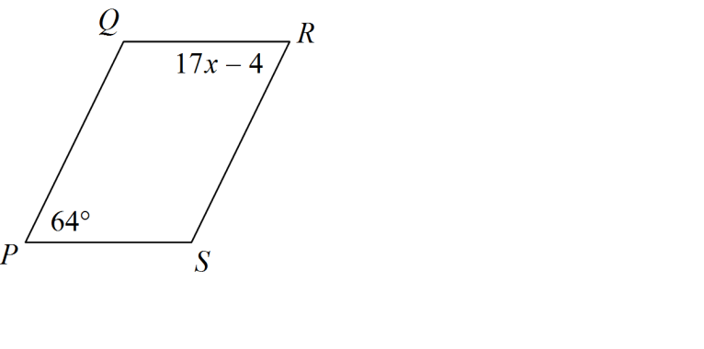

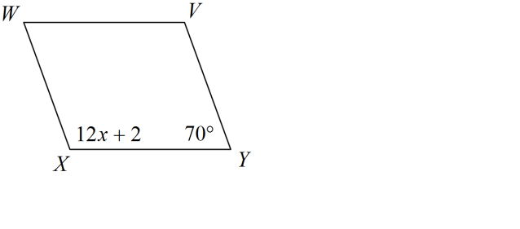1. 2.

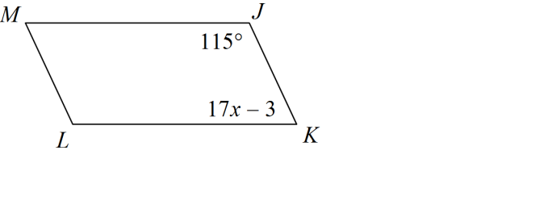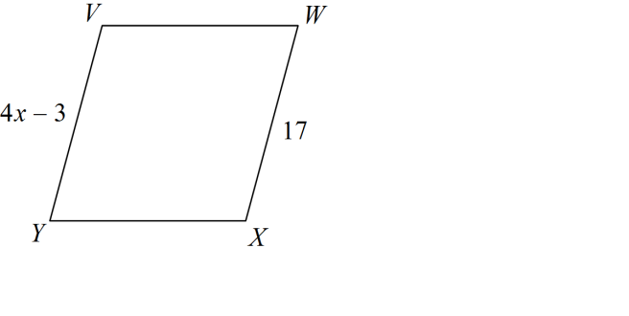

3. 4.

5. ABCD is a rhombus. If m<8=35°, 6. ABCD is a rectangle. If m<1=20° find the

Find the measure of <1, <2, <3, <4, measures of <2, <3, <4, <5, <6.

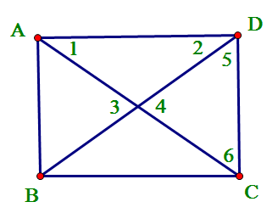<5, <6, <7.

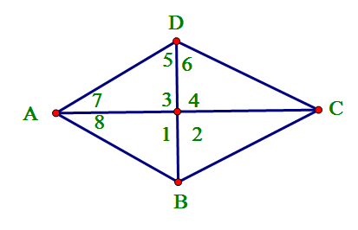

7. ABCD is a square. If AC=16in and 8. ABCD is a parallelogram. AR= 2x+ 3,

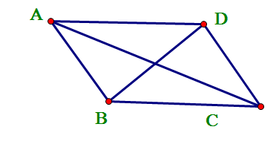BD = 2x + 4, find x. RC= 35, BR= 4y – 10, DR= 90. Find x and y.

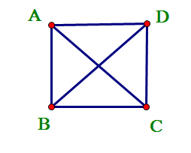

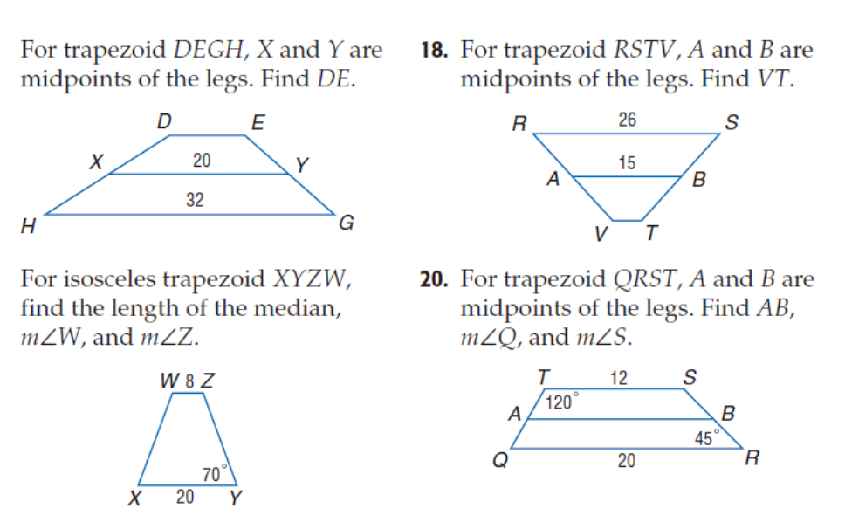

10.

9.





12.

11.

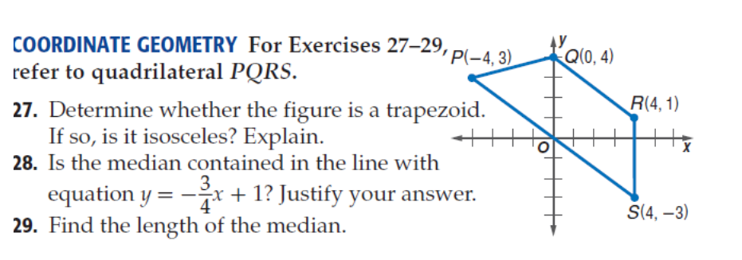13. a) Is the figure a trapezoid? Is it an isosceles trapezoid?

Explain, using math, how you know.

b.) Find the midpoints of PQ and RS and draw the median.

Challenge:

1.

2. Determine whether the figure is a trapezoid, a parallelogram, a square, a rhombus or a general quadrilateral given the vertices

B(1,2), C(4,4), D(5,1) and E(2,-1). SHOW ALL WORK in your explanations.

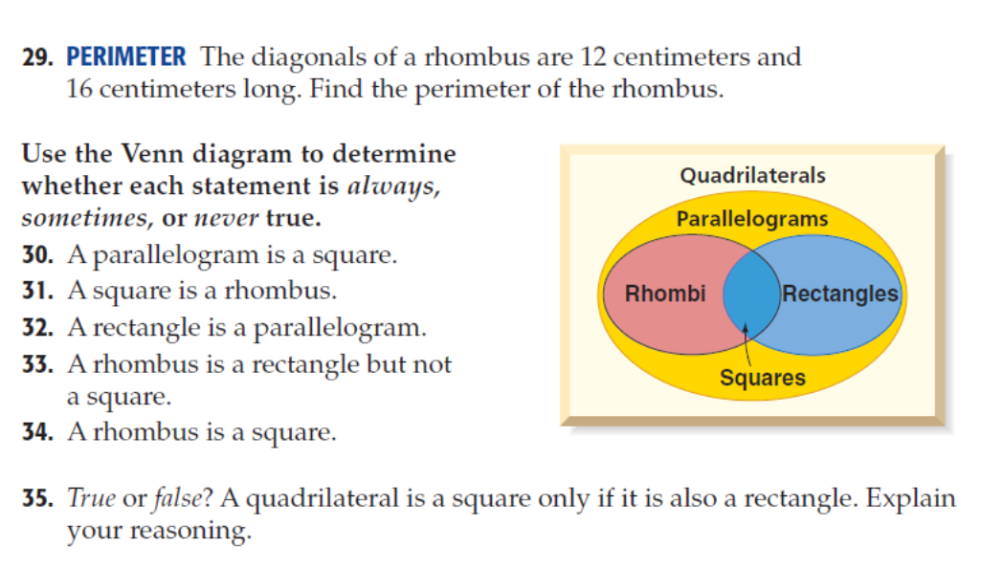

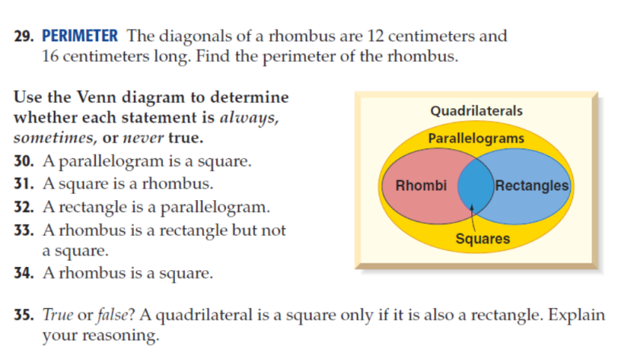3. 4.

-

-

-

-

-

5. 6. True or false? “*A quadrilateral is a square if and only of it is also a rectangle*.” Explain.

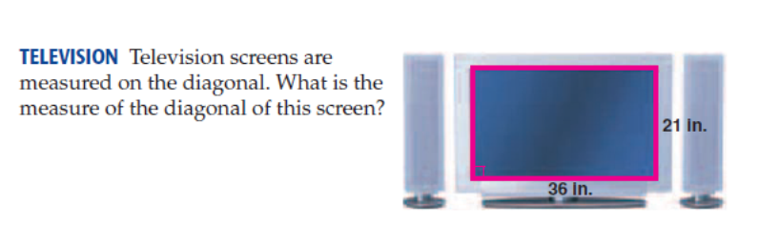

7. Find x and y if ABCD is a rectangle 8.

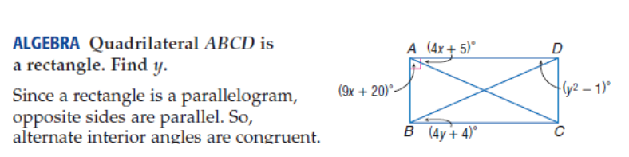



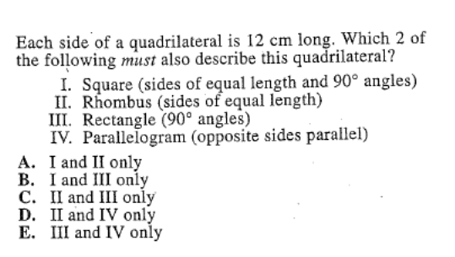9. ACT QUESTION! 10. ACT QUESTION!

Find x and y if the perimeter is 39m.

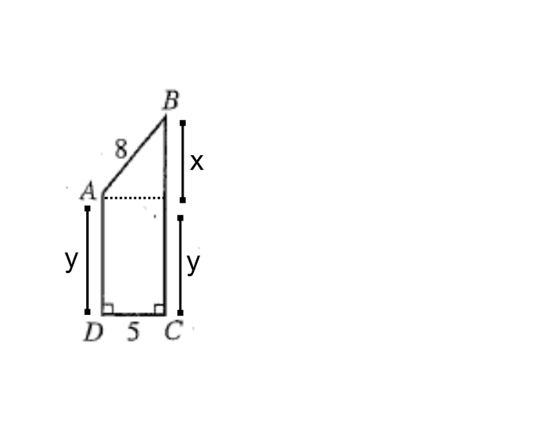

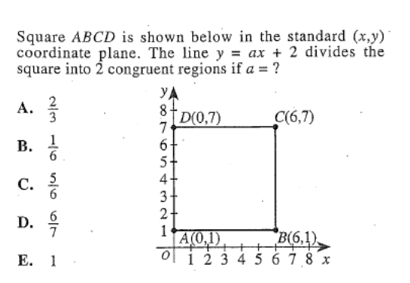11. ACT QUESTION! 12. ACT QUESTION!

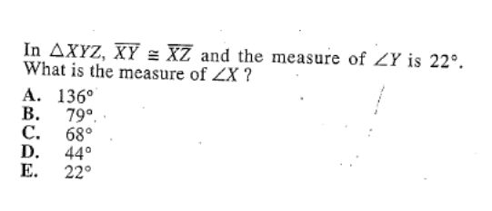

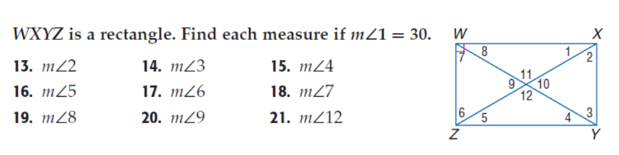

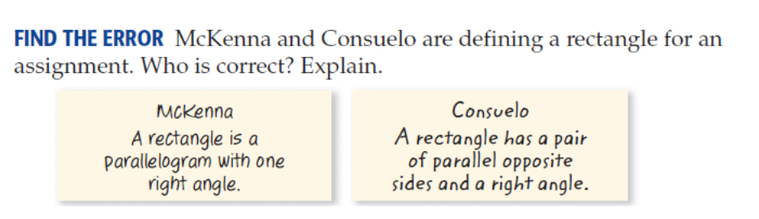22.

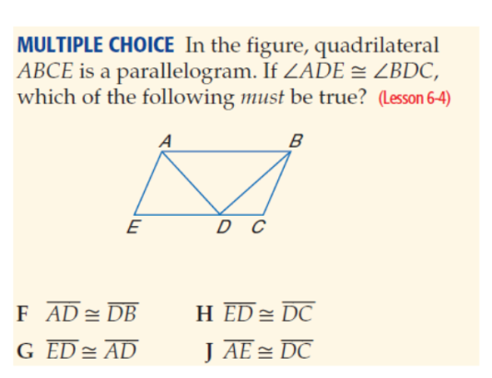

23.

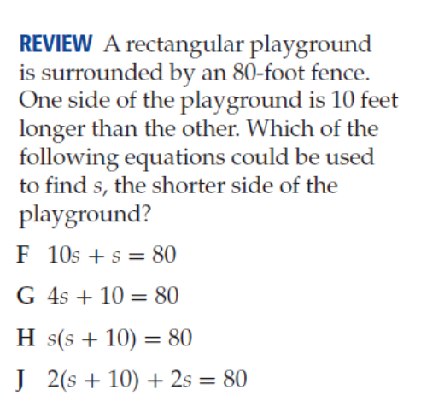

24.

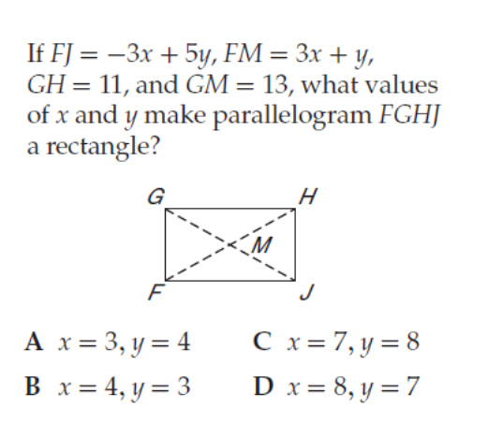

25.