Angle Relationships Day 3 HW

Find the value of the variable and find the m<PQR. Justify steps!

1.

2. In the figure, $\vec{EA} and \vec{EB}$ are opposite rays.
$\vec{EF}$ bisects $<AEC$, $<AEF=4\left(x^{2}-x\right)$ and $<FEC=35°$.
Find the possible values for x. Make sure to check your work and justify your steps.

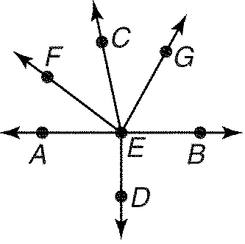

3. $m<11={2x}^{2}-7x+95, m<12={6x}^{2}-3x+88$. Find the possible value(s) for x. Make sure to justify your steps and check your work.
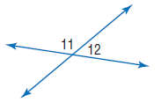

4. $m<17={10x}^{2}-25x, m<18={-4x}^{2}+6$. Find the possible value(s) for x. Make sure to justify your steps and check your work.

Rapid Practice: No justifications!

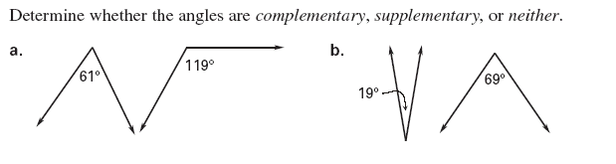
5.

6.

Decide whether the statement is true or false. If the statement if false, reword the statement so it is true.

7. Two angles are complementary if the sum of their measures is 180°

8. Two angles are supplementary if the sum of their measures is 180°

9. Two angles are adjacent angles if they share a common vertex.

Determine whether the angles are complementary, supplementary or neither.
10. 11. 12.

Find the measure of the complement of the given angle.
13. 14. 15.

Find the measure of the supplement of the given angle.
16. 17. 18.

Find the measure of EACH numbered angle.
19. 20. 21.

22. 23. 24.

