Name: ___________________________________________________________________________________________

Angle Relationships Quiz Review

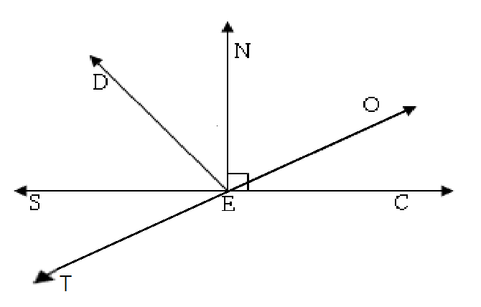**Directions:** Use the diagram above to find the following. For each question you must show your geometry and justify your set up. Remember each question is independent and does not carry onto the next question. This diagram is not drawn to scale.

1. If and find x.

Geometry Justification

X= ___________



2. If and find x.

Geometry Justification

X= ___________



3. If and find x.

Geometry Justification

X= ___________

4. If and find x.

Geometry Justification

X= ___________



5. If and find x.

Geometry Justification

X= ___________



6. If and find x.

Geometry Justification

X= ___________

7. Find x and the if

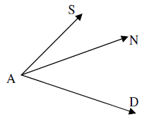

8. Find x and the if



9. Find x and the if



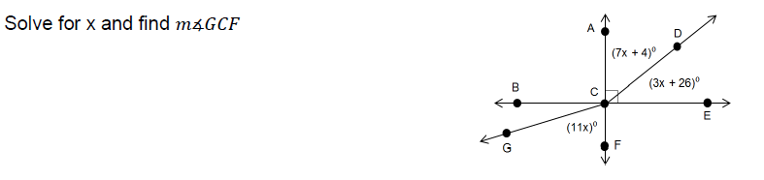10.



11. Find x and the if

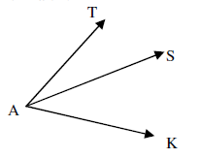

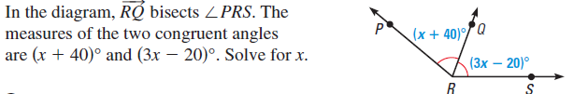12.





13.

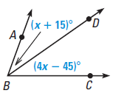

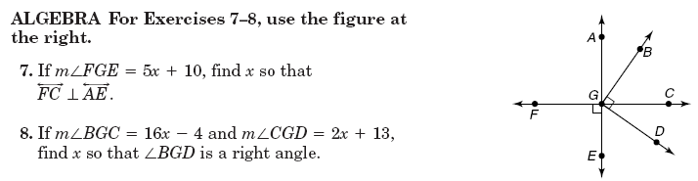

14. If  and , find x.



def of perpendicular or right angle

15. If , , and , find x.



16. Find the value(s) of x if

$\vec{AS} bisects ∠KAT$, $m∠SAT={2x}^{2}-9x-12 and m∠KAS={-2x}^{2}-18x-3$





x = _______________________