Name: _________________________________________________________________________

In Class Practice- Regular Polygons

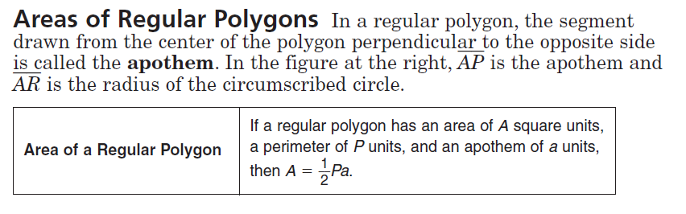**Radius/Apothem/Side Length**

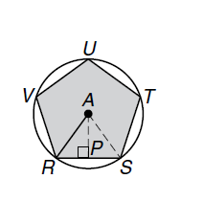**Find the area of the pentagon if**

**1. AR = 41 ft**

**2. AP= 13 in**

**3. UT= 7cm**

**4. Perimeter = 105 km**

**In-Class Discussion**

**ACT: Use the area formula of a regular polygon given as A=1/2 a P, where a is the apothem and P is the perimeter. How is this derived from the area of a triangle with vertex angle of each triangle at the center of each figure?**

1.  Find the area of the regular polygon.
2. **Find the area of a regular hexagon if the apothem length is $5\sqrt{3 }cm.$**

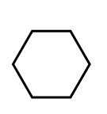

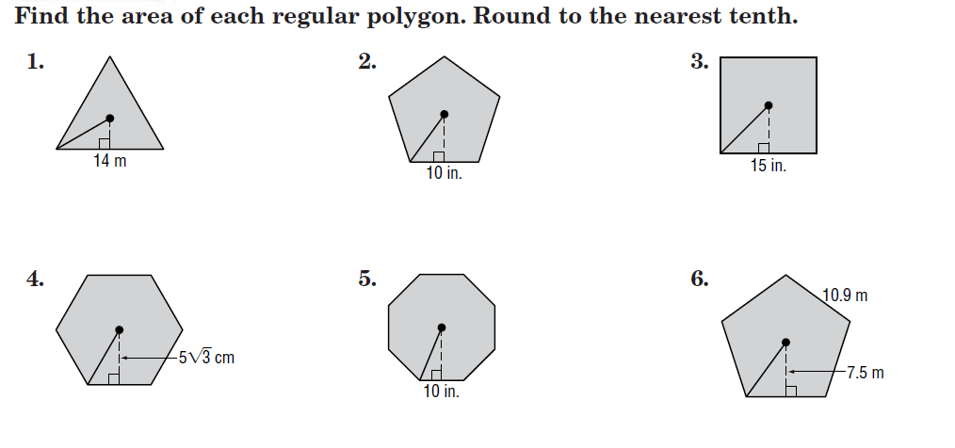**CCSS:**

