Name: _____________________________________________________________
Area of Regular Polygons Practice (day one)
Find the area of each REGULAR polygon, rounding to the nearest tenth.
1. 2.

18m

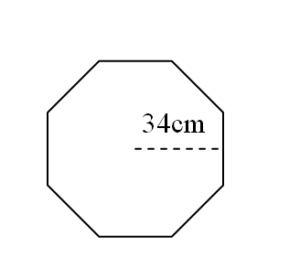
3. 4.

5. s = 12in 6. S = 21km

7. Find the area of a regular nonagon with perimeter of 90cm.

8. Find the area of a regular dodecagon with perimeter of 120m.

9. Find the area of a regular triangle with perimeter of 21 km.

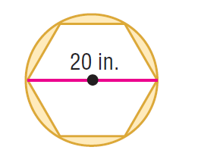
Find the area of each shaded region , rounding to the nearest tenth.

10. 11. .

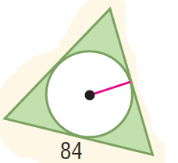
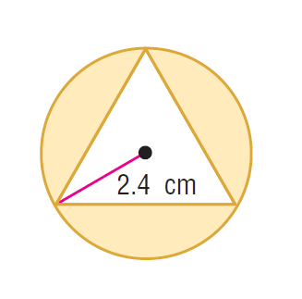

12. 13.

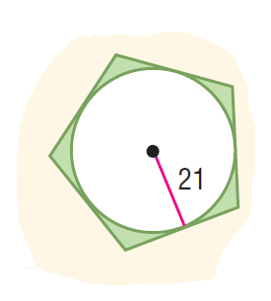
14. 15.

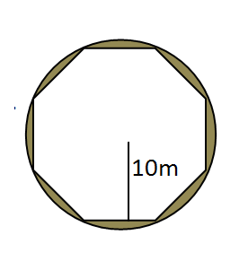
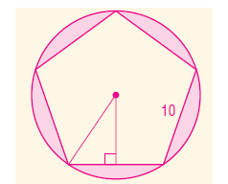

16. 17.

