Name: _________________________________________________ Hour: ______________

Basic Area Warm-Up

***Show all formulas, steps and work, then circle all final answers!***

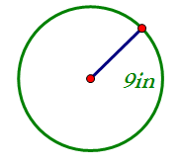1. Find the area of the circle. KEEP IN TERMS OF !!!!

**Find the area of the following figures. Round to the nearest tenth if needed and circle all answers.**

2. 3.

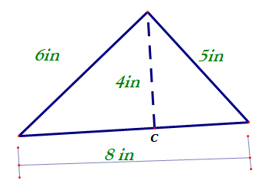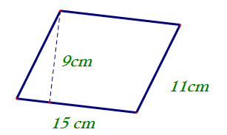

4.

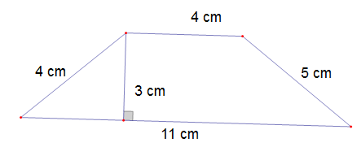

Name: _________________________________________________ Hour: ______________

Floor Plan Warm-Up

***Show all formulas, steps and work, then circle all final answers!***

Directions: Use the following picture to answer the following questions.



1. Find x, y, and z.

2. The Trpovskis are planning to carpet the bedroom, hallway and TV Room. Find the amount of carpet they need to buy in square footage. Show all work.

3. While placing the order for the carpeting, they run into a problem, they must order the carpet in square yards. Find the amount of carpet they must buy in square yards.

Name: _________________________________________________ Hour: ______________

Another Floor Plan Warm-Up

***Show all formulas, steps and work, then circle all final answers!***

Directions: Use the following picture to answer the following questions.



1. Find x, y, and z.

x = __________ y = ___________ z =_________________

2. The Robinsons are planning to carpet the study, hallway and TV Room. Find the amount of carpet they need to buy in square footage. Show all work.

3. While placing the order for the carpeting, they run into a problem, they must order the carpet in square yards. Find the amount of carpet they must buy in square yards.

Name: _________________________________________________ Hour: ______________

One More Floor Plan Warm-Up

***Show all formulas, steps and work, then circle all final answers!***

Directions: Use the following picture to answer the following questions.



1. Find x, y, and z.

x = __________ y = ___________ z =_________________

2. The Sabatini’s are planning to put wood floor the bathroom, kitchen and master bedroom. Find the amount of flooring they need to buy in square footage. Show all work.

3. While placing the order for the carpeting, they run into a problem, they must order the carpet in square yards. Find the amount of carpet they must buy in square yards.

Name: _________________________________________________ Hour: ______________

Special Missing Parts #1 Warm-Up

***Show all formulas, steps and work, then circle all final answers!***

**Find the exact area for each polygon.**

1. 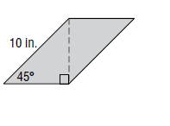

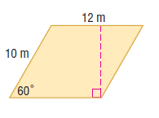



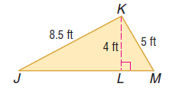



Name: _________________________________________________ Hour: ______________

Special Missing Parts #2 Warm-Up

Directions: Use special right triangles to find the area. You must show formulas, work, leave your answers in EXACT form and circle your final answers.

1. 2.

in



3. 4.

Name: _________________________________________________ Hour: ______________

Missing Parts Warm-Up

Directions: Find the missing part of the figure given the area, round to the nearest tenth. Circle your final answers and don’t forget units!!!

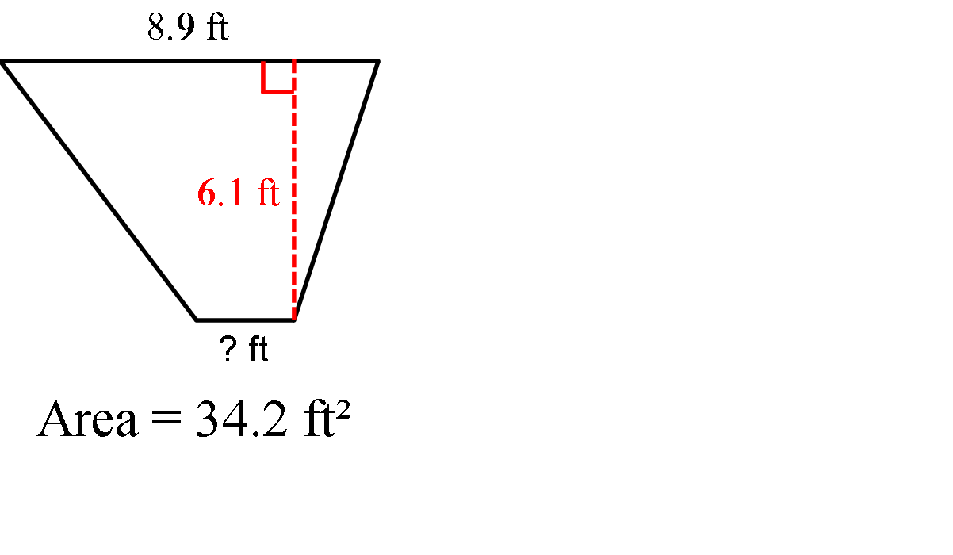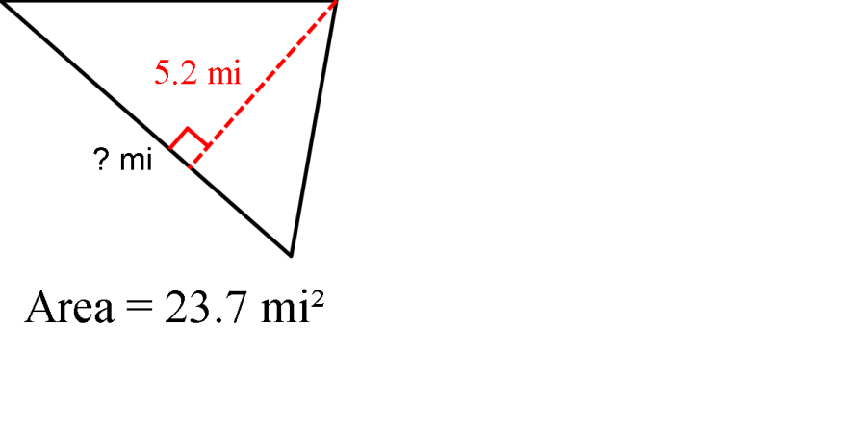1. 2.

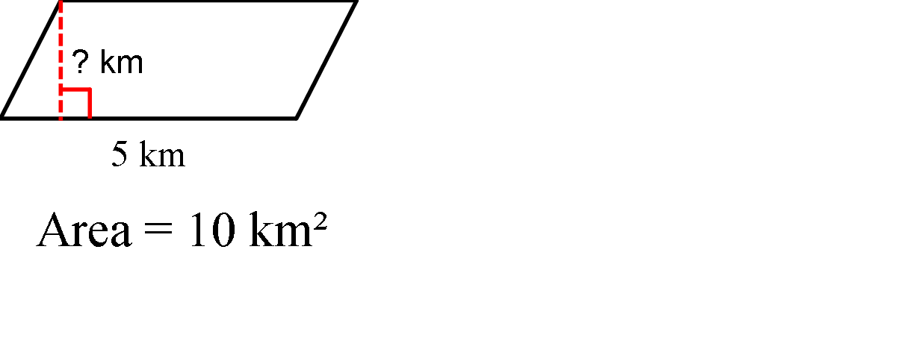3. 4. Find the missing parts, then find the area.



Name: _________________________________________________ Hour: ______________

Coordinate Area #1 Warm-Up

Directions: Find the area. You must show formulas, work, leave your answers in EXACT form and circle your final answers.

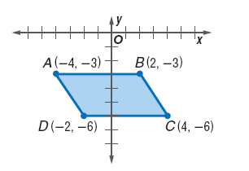1.

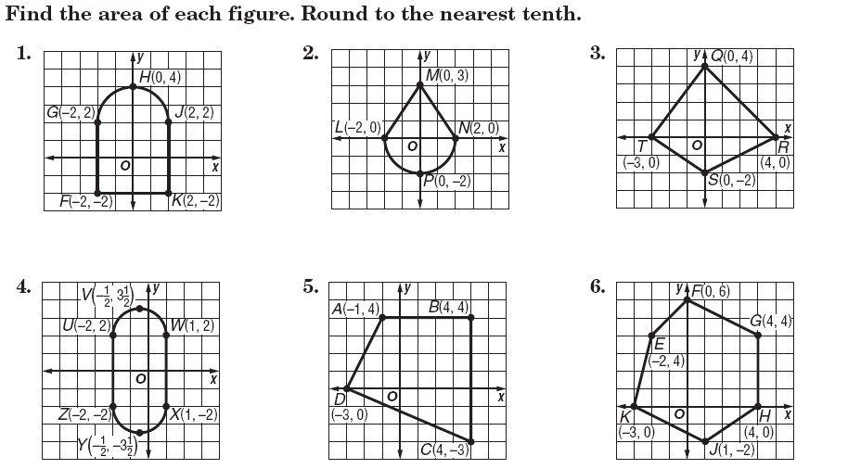

2.

Name: _________________________________________________ Hour: ______________

Coordinate Area #2 Warm-Up

Directions: Find the area. You must show formulas, work, leave your answers in EXACT form and circle your final answers.

1. In the standard coordinate plane below, the points and are the vertices of a parallelogram. What is the area, in square units, of the parallelogram?

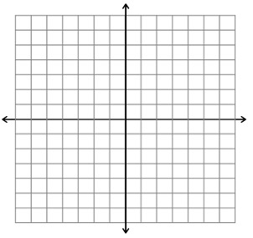

2. In the standard coordinate plane below, the points $\left(2,5\right), \left(8,5\right), \left(7,1\right),$ and $(1,1)$ are the vertices of a parallelogram. What is the area, in square units, of the parallelogram?



Name: _________________________________________________ Hour: ______________

Area of Composite Figures #1 Warm-Up

Directions: Find the area. You must show formulas, work, leave your answers in EXACT form and circle your final answers.

1. Max wants to put in hardwood floors in his kitchen (rectangle) and his dining room (trapezoid). Find the area needed to put in wood floors.

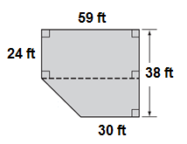

2. The trapezoid below is divided into $2$ triangles and $1$ rectangle. Lengths are given in inches. What is the shaded area?



Name: _________________________________________________ Hour: ______________

Mixed Up Warm-Up

Directions: Find the area. You must show formulas, work, leave your answers in EXACT form and circle your final answers.

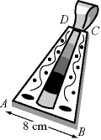

1. A goldsmith designed a trapezoidal pendant as shown in the figure. If the height of the trapezoid is 10 centimeters and **area** of the pendant *ABCD* is 50 square centimeters, **find the length of the side *CD*.**

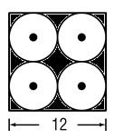

**2.** A gardener installs 4 sprinklers in a square plot with sides that are 36 feet long.  Each sprinkler waters a circular region with a radius of 9 feet, as shown below.  No portion of the plot is watered by more than 1 sprinkler.  What is the approximate area, in square feet, of the portion of the plot that is NOT watered by a sprinkler?

Name: _________________________________________________ Hour: ______________

Applications #1 Warm-Up

Directions: Find the area. You must show formulas, work, leave your answers in EXACT form and circle your final answers.

1. A rectangular window, measuring 6 feet by 4 feet, is surrounded by a plastic frame which is 1 foot wide. What is the area of the window, including the frame?





2. Using this circular life raft. Find the area of the top of the raft using the given information*.*

16 in.

6 in.

Name: _________________________________________________ Hour: ______________

Applications #2 Warm-Up

Directions: Find the area. You must show formulas, work, leave your answers in EXACT form and circle your final answers.

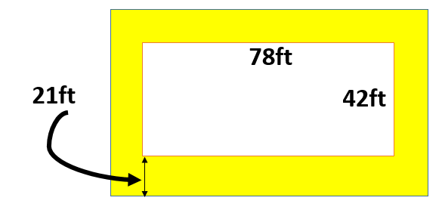1. Find the area of the shaded regions for both images.

2. Find the area of the shaded region.

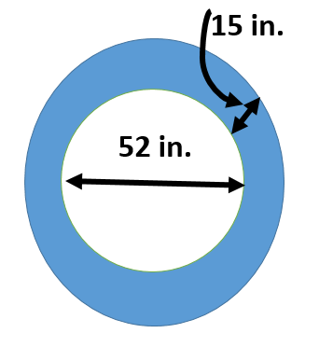

Name: _________________________________________________ Hour: ______________

Floor Plan #2 Warm-Up

***Show all formulas, steps and work, then circle all final answers!***

Collin's family is ready to have wall-to-wall carpeting installed. The carpeting they chose costs $12 per square yard, the padding $2 per square yard, and the installation $3 per square yard. What will it cost them to carpet the three bedrooms? Measurements written as "17/4" represents 17 feet, 4 inches.

[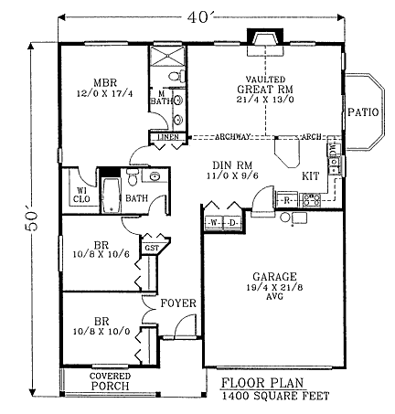](http://www.dreamhomesource.com/Plan.asp?PlanID=18207&SquareFeetMin=1000&SquareFeetMax=1400&BedroomsMin=3&BedroomsMax=3&BathroomsMin=20&BathroomsMax=20&FloorsMin=1&FloorsMax=1&SortBy=SFD&Record1=1&RecordN=9##)