Name: _________________________________________________________

HW: Basic Surface Area & Volume of Cylinders, Cones, and Spheres

Directions: Identify each figure, find the surface area and volume of the following figures. You must write the formula you used first. Keep all answers in terms of pi, then show the rounded value to the nearest thousandth.

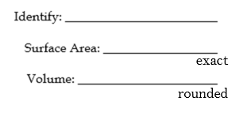
1.

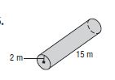

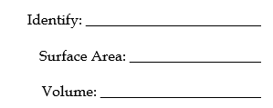
2.

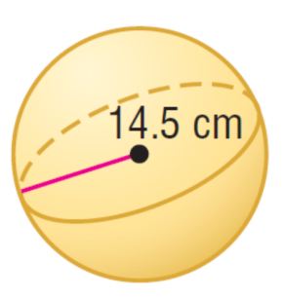
3.

4.

5.

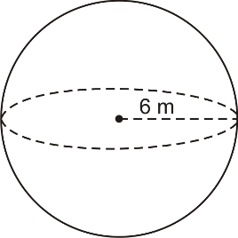
6.

