GEOMETRY Name_________________________
CONGRUENT TRIANGLES PROOFS

Write a two column proof for the following problems.
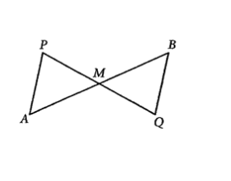

- Given: M is the midpoint of $\overline{AB}$ and $\overline{PQ}$
Prove: $∆APM ≅∆QBM$

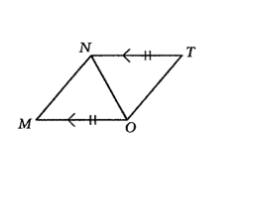

- Given: $\overline{NT }$ is parallel and $≅$ to $\overline{MO}$
Prove: $<M≅ <T$

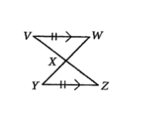
- Given: $\overline{VW }$ is parallel and $≅$ to $\overline{YZ}$
Prove: $∆XVW ≅ ∆XZY$

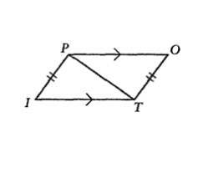

- Given: $\overline{PO }$ is parallel to $\overline{IT}$
$\overline{PI} ≅ \overline{TO}$
<O ≅ <I
Prove: $PO ≅ IT$

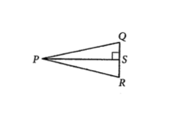

- Given: $\overline{PS }$ is the angle bisector of $<QPR$
<QSP≅<RSP
Prove: S is the midpoint of QR

