Name: ________________________________________________________________
Converting Degrees to Radians HW 2016-2017

1. Explain how arc length is used to convert degrees to radians. Use the conversion of 210ᵒ to $\frac{7π}{6}$.

2. Explain how arc length is used to convert degrees to radians. Use the conversion of 270ᵒ to $\frac{3π}{2}$.

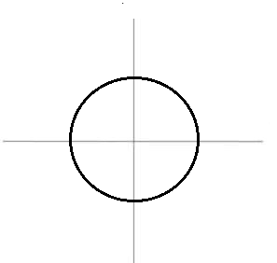
3. In the circle with center C, with the central angle ACD measuring $\frac{5π}{6 }$ radians complete the following:

a. Sketch the angle.
b. Shade in the portion of the circle which is $\frac{5π}{6 }$ radians.
Is the shaded region larger or smaller than $π$ radians.

c. What fraction of the area of circle has been shaded?
Explain how you came to fine your answer mathematically.

4. In the circle with center C, with the central angle ACD measuring $\frac{7π}{4 }$ radians complete the following:
a. Sketch the angle.
b. Shade in the portion of the circle which is $\frac{7π}{4 }$ radians.
Is the shaded region larger or smaller than $π$ radians.

c. What fraction of the area of circle has been shaded?
Explain how you came to fine your answer mathematically.

With the unit circle having the radius of one unit, finding the arc length is converting the degrees to radian measure

5. Convert the central angle with measure 135$°$ to radians.

6. Convert the central angle with measure 330$°$ to radians.

7. Convert $\frac{2π}{3}$ radians to degrees.

8. Convert $\frac{3π}{4}$ radians to degrees.

9. Convert $\frac{π}{2}$ radians to degrees.

10. Convert $\frac{π}{3}$ radians to degrees.

11. The traditional method of converting radians to degrees is to multiply the radian by $\frac{180}{π}$. Explain WHY this method works.

