Coordinate Geometry Day 1 HW

Determine whether the figure is a parallelogram, rectangle, rhombus, square or just a general quadrilateral. Explain your reasoning. (Classify all that apply)

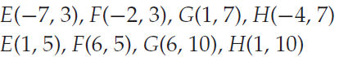

1.

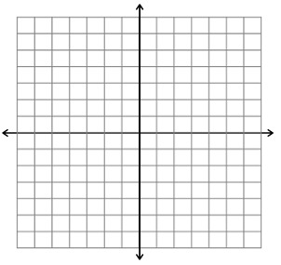

Distances:

Slopes:

Conclusion:

EFGH __________ a parallelogram because _______________________________________________

EFGH __________ a rhombus because ___________________________________________________

EFGH __________ a rectangle because ___________________________________________________

EFGH __________ a square because _____________________________________________________

(is or is not)



2.

[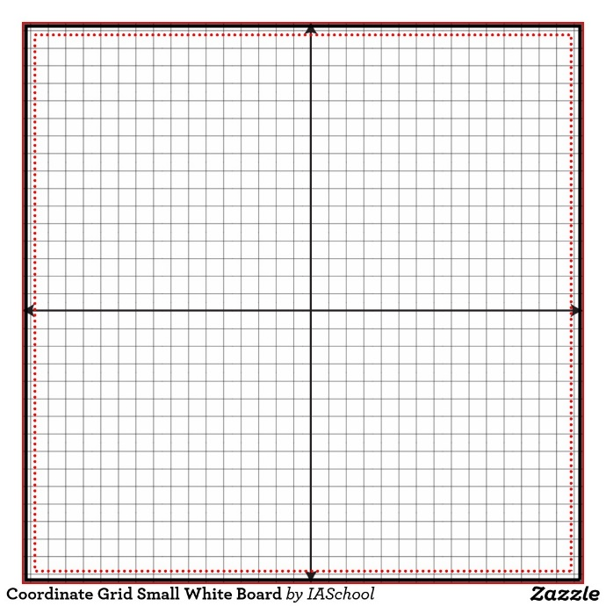](http://www.google.com/url?sa=i&rct=j&q=&esrc=s&source=images&cd=&cad=rja&uact=8&ved=0CAcQjRxqFQoTCMmbhvbMiMkCFQkZPgod6a4JrQ&url=http://www.zazzle.com/coordinate_grid_small_white_board_dry_erase_boards-256261832696438728&psig=AFQjCNHs-KHUVDvPwubE8mAOu6_udtd-pA&ust=1447339193075505)

Distances:

Slopes:

Conclusion:

EFGH __________ a parallelogram because _______________________________________________

EFGH __________ a rhombus because ___________________________________________________

EFGH __________ a rectangle because ___________________________________________________

EFGH __________ a square because _____________________________________________________

(is or is not)

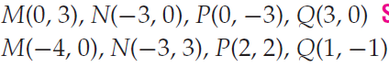3.



Slopes:

Distances:

Conclusion:

MNPQ __________ a parallelogram because _______________________________________________

MNPQ __________ a rhombus because ___________________________________________________

MNPQ __________ a rectangle because ___________________________________________________

MNPQ __________ a square because _____________________________________________________

(is or is not)



4.



Slopes:

Distances:

Conclusion:

MNPQ __________ a parallelogram because _______________________________________________

MNPQ __________ a rhombus because ___________________________________________________

MNPQ __________ a rectangle because ___________________________________________________

MNPQ __________ a square because _____________________________________________________

(is or is not)

Solutions:

1. rhombus para

2. square, rectangle, para, rhombus

3. square, rectangle, para, rhombus

4. none