Coordinate Geometry and Composite Figures HW #1
Find the area of each composite figure. You must show all work. Don’t forget your units!
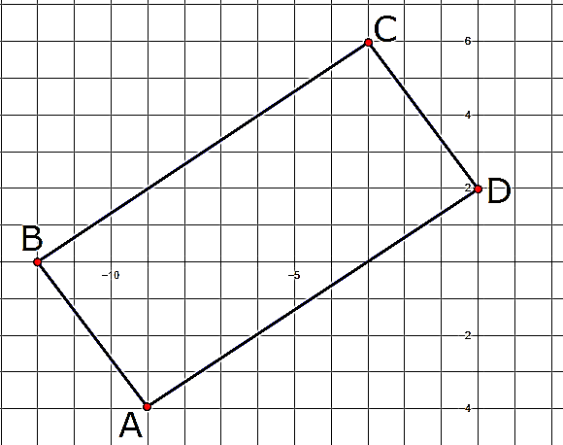
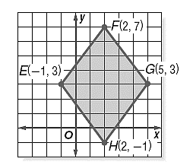
1. 2.

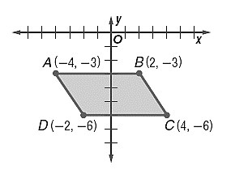
3. 4.

5.

6.

7.

