Name: _______________________________

10-8 Equations of Circles: HW

C:\Documents and Settings\kschmidt\Local Settings\Temporary Internet Files\Content.IE5\6FCI7GFZ\MC900351973[1].wmf

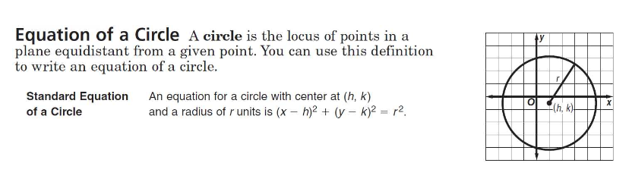

Write the equation for each circle, then graph each.

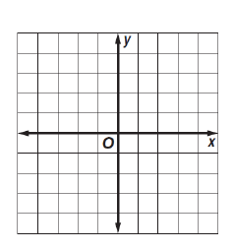

1. Center at (-1,0), r=4

2. Center at (1,-1) , r = 3

3. Center at ( -6,-4), r = 2

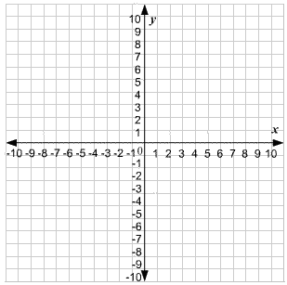

Find the center and the radius and graph each equation.

4. 5. 6.



Center: Center: Center:

r = r = r =

7. Write the equation of a circle with the center at (-5,3) and a radius with the endpoint (2,3).

8. Write the equation of a circle with the center at (-2,-7) and a radius with the endpoint (0,7).

9. Write the equation of a circle with the center at (7,-2) and a radius with the endpoint (1,-6).

10. Write the equation of a circle whose diameter has endpoints (4,6) and (-2,6).

11. Write the equation of a circle whose diameter has endpoints (-7,1) and (-7,9).

12. Write the equation of the unit circle.

13. Communications: When you make a call on a cellular phone, a tower receives the call. The equation ${(x-16)}^{2}+(y-10)^{2}=100$ models the position and range of tower A. A new tower, tower B, is to be built on the location graphed. Write the equation that describes tower B’s position and range. A competing provider builds a different tower, tower O, is to be built on the location graphed. Write the equation that describes tower O’s position and range.

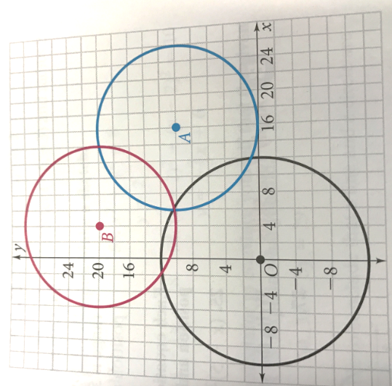

14. a. Graph the circle with the equation ${(x-2)}^{2}+{(y+2)}^{2}=9$.

b. Graph and write an equation of another circle which is tangent to the one given.

c. Graph and write an equation of a third circle which is NOT tangent to the circle given, nor the circle from part a, and has a center at the origin.



15. The 2 circles ${\left(x+5\right)}^{2}+{\left(y+5\right)}^{2}=25$ and ${\left(x-5\right)}^{2}+{\left(y-5\right)}^{2}=25$ are graphed in the standard $(x, y)$ coordinate plane below. Which of the following circles, when graphed, will be tangent to both circles.

$x^{2}+y^{2}=4$ ${\left(x+5\right)}^{2}+{\left(y-5\right)}^{2}=25$ ${\left(x+5\right)}^{2}+{\left(y+5\right)}^{2}=25$