Name: _______________________________ Date______________

Exact Values for Sine, Cosine & Tangent in degrees

Method 1: Using Special Right Triangles to find exact values
1.) Sketch the angle
2.) Label the reference angle
3.) Draw a triangle to the x-axis and label its sides
4.) Find the trig value
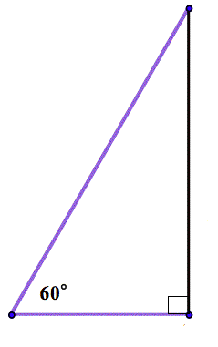
Recall special right triangles

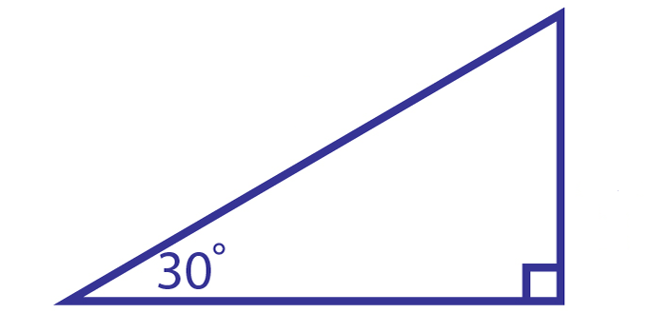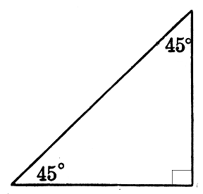

Directions: Find the exact values of each trigonometric function:
1. sin 225ᵒ. ______ 2. tan 330ᵒ. _____
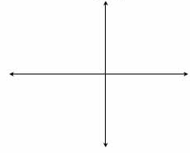

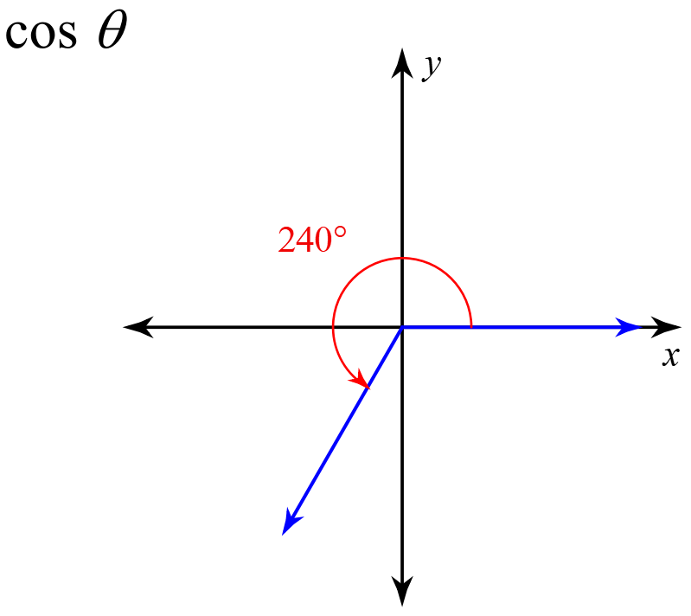
3. 4. cos -210ᵒ. ______

5. tan 240ᵒ. ________ 6. sin -150ᵒ.______

Practice with Coterminals!
Directions: Find the exact values of each trigonometric function:
1. Find the exact value of sin -600ᵒ. ______ 2. Find the exact value of tan 405ᵒ. _____

3. Find the exact value of cos 510ᵒ. ______ 4. Find the exact value of cos -690ᵒ. ______

Finding a ratio given another ratio
1.) Construct the triangle on the coordinate plane.
2.) Label the reference angle in degrees.
3.) Find the length of the missing side. Be sure to watch out for negatives!
4.) Find the value of the other ratio.

7. If $sinθ=\frac{1}{2}$ and in quadrant II, find cos $θ$ .
a) What is the value of the reference angle?

b) cos =

c) What is angle $θ?$

8. If $cosθ=-\frac{1}{2}$ and in quadrant III, find tan $θ$:
a) What is the value of the reference angle?

b) tan =

c) What is angle $θ?$

9. If $sin θ=\frac{1}{2}$ and in quadrant I, find cos $θ$:
a) What is the value of the reference angle?

b) cos =

c) What is angle $θ?$

10. If $cosθ=-\frac{\sqrt{3}}{2}$ and in quadrant III, find tan $θ$:
a) What is the value of the reference angle?

b) tan =

c) What is angle $θ?$

