Name: ______________________________________________________________________
Final Exam Prep Individual Practice

Volume Exercises
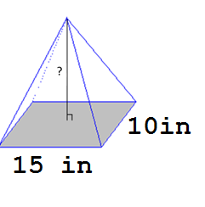

1. The volume of the pyramid shown is 300 in³. What is the height of the pyramid?

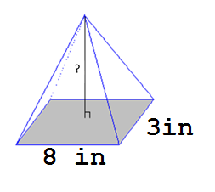
2. The volume of the pyramid shown is 96 in³. What is the height of the pyramid?

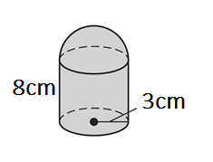
3. Find the volume of the composite solid made of a cylinder and hemisphere. Round to the nearest tenth in cubic centimeters.

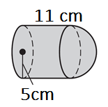
4. Find the volume of the composite solid made of a cylinder and hemisphere. Round to the nearest tenth in cubic centimeters.

5. In order to clean her aquarium (which is a rectangular prism), Bianca must remove half of the water. The aquarium measures $80$ inches long, $25$ inches wide, and $13$ inches deep. The aquarium is currently completely full. What volume of water, in cubic inches, must Bianca remove?

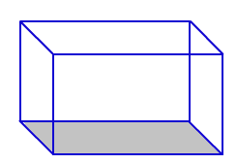

6. In order to clean her aquarium (which is a rectangular prism), Bianca must remove a fourth of the water. The aquarium measures $45$ inches long, $30$ inches wide, and $17$ inches deep. The aquarium is currently completely full. What volume of water, in cubic inches, must Bianca remove?

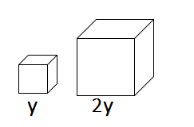
7. A large cube has edges that are double as long as those of a small cube. The volume of the large cube is how many times the volume of the small cube?

8. A large cube has edges that are triple the length as long as those of a small cube. The volume of the large cube is how many times the volume of the small cube?
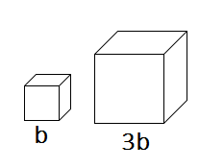

9. An ice cream cone is 12 centimeters deep and has a diameter of 9 centimeters. A spherical scoop of ice cream that is 9 centimeters in diameter rests on the top of the cone. If all the ice cream melts into the cone, will the ice cream overflow? Explain.

