Individual Practice:
Basic Constructions of Reflections

Reflect the given figure over the given line.

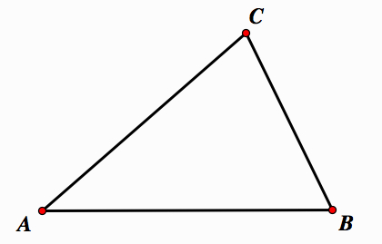
1.

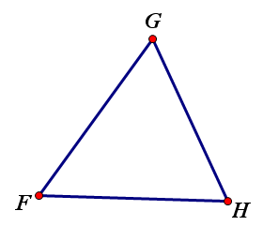

2.

Using a Protractor- The Basics
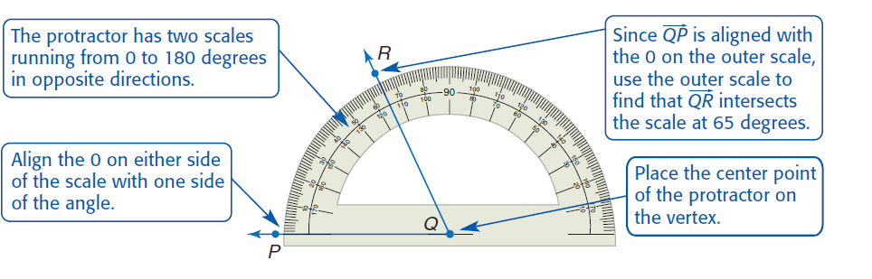

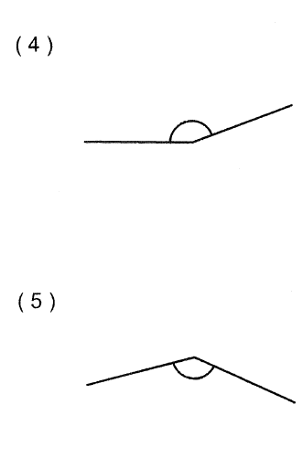
Directions- Classify each angle as right, acute or obtuse, and then measure the angle with a protractor. Don’t forget your units as degrees!
