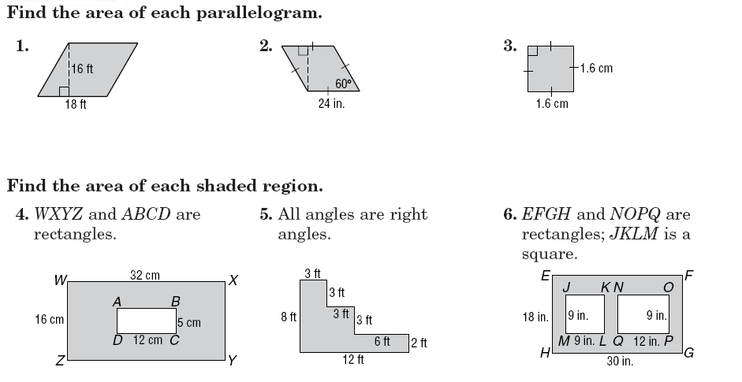
Individual Practice-Intro to Area

7. The Smiths are planning to carpet part of their house. The carpet they plan to buy is sold by the square foot. If the carpet costs $4 per square foot. Find the cost of the carpeting if they want to carpet the living room, den, and hall. They want to tile the bathroom and kitchen floor. The tile is 1ft x 1ft and costs $6.75 per tile. What is the cost to tile that area?

Find the area of each figure (round to the nearest tenth).
8. 9.

10. 11. 12.

