Name: _____________________________________ Date: __________

Recalling Area, Finding Missing Length Figures Homework

Find the area of each figure.

1. 2.



3. 4. 



5. 6. 



7. 8.

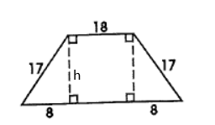

9. 10.

11. 12. 

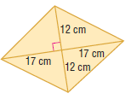

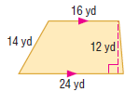13. 14.

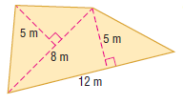

15.

16. The Sibleys are tiling their kitchen and bathroom. Find the area of the bathroom and kitchen. If each tile is 6 inches by 6 inches, how many tiles will the Sibleys need?

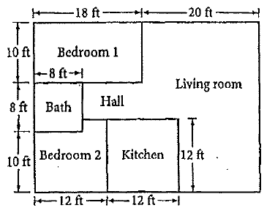

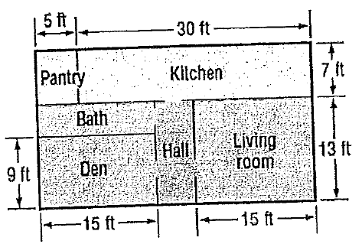17. The Smiths are planning to carpet part of their house. The carpet they plan to buy is sold by the square yard. Find the amount of carpeting needed to cover the living room, den, and hall if all are rectangular rooms. (3 ft = 1 yd)