Isosceles and Equilateral Triangles Practice (Day 2)
1. Answer: True or False.

- ∆ABC is a right triangle __________
- ∆BED is an obtuse triangle _________
- ∆BED is equilateral ___________
- ∆EDC is a right triangle __________
- <ABC is 90 degrees _________

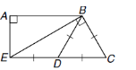
2. Answer: True or False.
- ∆ABE is a right triangle __________
- ∆BED is an obtuse triangle _________
- ∆BED is isosceles ___________
- ∆EBC is a right triangle __________
- <DBC is 90 degrees _________
- ∆BDC is equilateral ___________
- <D is the vertex angle of ∆EDB ________
- <C is 60 degrees __________

Use the Triangle Sum Theorem to find the numbered angles listed below each figure.

<1= _____ m<1= ______

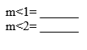
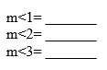

m<1= _______ m<1= _______

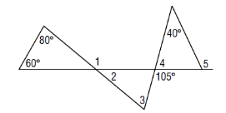

7.

m<1= ______ m<2 = _________
m<3= ______ m< 4= __________
m<5 = ______

8. Find the measure of each side of equilateral triangle RST with RS = 2x + 2, ST = 3x and TR = 5x – 4.

9. Find the measure of each side of isosceles triangle ABC with vertex angle <B, if AB = 4y, BC = 3y + 2, and AC = 3y.

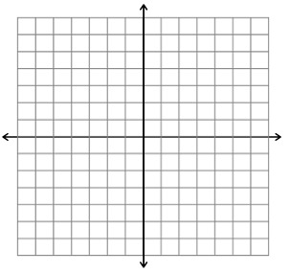
10.

