Area with Missing Parts Practice

**Directions:** Find the following for the rectangle.

1. Find the missing side length if the 2. Find the missing side length if the

area = 30 cm2  area = 42 cm2

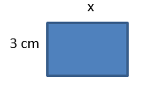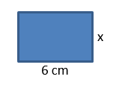

**Directions:** Find the following for the triangle.

3. Find the missing height if the 4. Find the missing base if the

area = 40 cm2  area = 63 m2

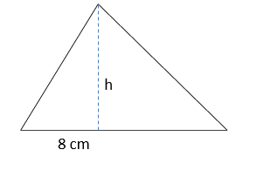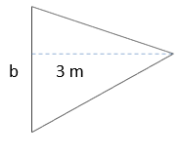

**Directions:** Find the following for the parallelogram.

5. Find the missing height if the 6. Find the missing base if the

area = 36 cm2  area = 18 m2

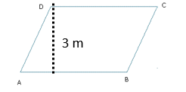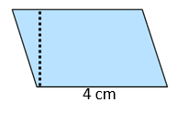

**Directions:** Find the following for the trapezoid.

7. Find the missing height if the 8. Find the missing base if the

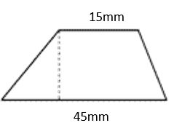area = 300 mm2  area = 50 m2

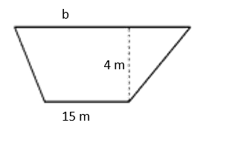

**Directions:** Find the following for the figures.

9. Find the missing height if the 10. Find NQ of the rhombus if the

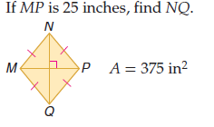trapezoid’s area = 750 m2  area = 375 in2

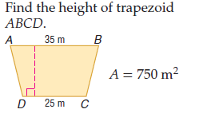

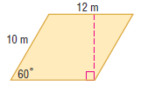For #11-, find the area using **special right triangles**. Answers must be exact values- no rounding!

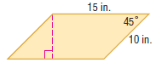11. 12.

13. 14.





15. 16.

17. Keisha designed a garden that is shaped like two congruent rhombi. She wants the long diagonals lined with a stone walkway. The total area of the garden is 150 square feet, the shorter diagonals (dashed) are each 12 feet long.

a.) Find the length of each stone walkway (longer diagonals).

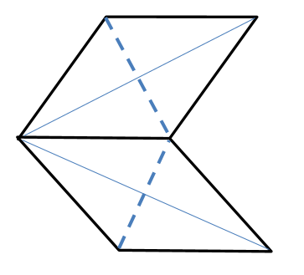

b.) Find the length of each side of the garden.