**Write a two-column proof for the following.**

**1. Given: $\overline{AB}≅\overline{CD}; \overline{AB}‖\overline{CD}$**

**Prove: ΔABC ≅ ΔCDA**



**2. Given: $\overline{PQ}$ bisects <SPT**

$\overline{SP}≅\overline{PT}$

**Prove: Δ SPQ ≅ ΔTPQ**



**3. Given: $\overline{AD}‖\overline{CE}; \overline{BD}≅\overline{BC}$**

**Prove: ΔABD ≅ Δ EBC**



**4. Given: $\overline{AB}$ $\overline{AD}$**

$\overline{DE}\overline{AD}$

**C is the midpoint of $\overline{BE}$**

**Prove: < ABC ≅< DEC**



**5. Given: $\overline{AO}\overline{BC};<B≅<C$**

**Prove: Δ AOB = Δ AOC**



**6. Given: $\overline{AO}\overline{BC};<BAO≅<CAO$**

**Prove: Δ AOB = Δ AOC**

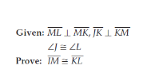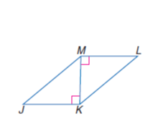**7.**



**8.Given: <BEF ≅ < BED**

**BE bisects <FBD**

**Prove: ΔFBE ≅ Δ DBE**



**9. Given: A is the midpoint of MT**

**A is the midpoint of SR**

**Prove: $\overline{MS}≅\overline{TR}$**