Name: _____________________________________________________________
Parallel Proofs A
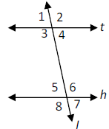
1. Given: t // h
Prove: <3 and <7 are supplementary.

2. Given: DE // BC and <1 <2
Prove: <3 <4

3. Given: p// q // r
Prove: <2 and <4 are supplementary

4. Given: HJ // LM, HG//LK
Prove: <5 <8

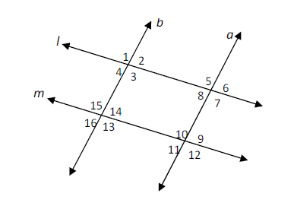
5. Given: a // b, l//m
Prove: <5 <13

6. Proof Review:

