Practice Examples: Parallelogram Properties HW DAY 1



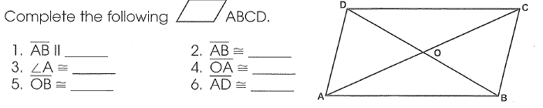

Angles of Parallelograms Practice:

Must show what property you used to come to the conclusion.

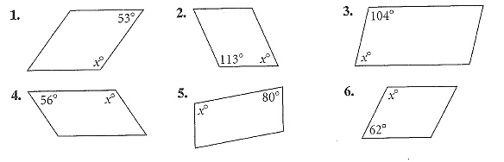



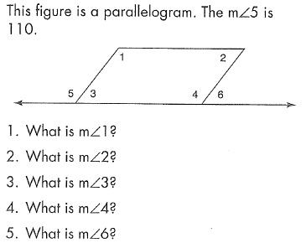More angles and some sides of Parallelograms:

Must show what property you used to come to the conclusion.

7. 8. The following is a paralleogram.

Name all congruent segments.…………..

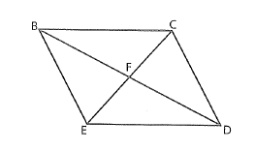

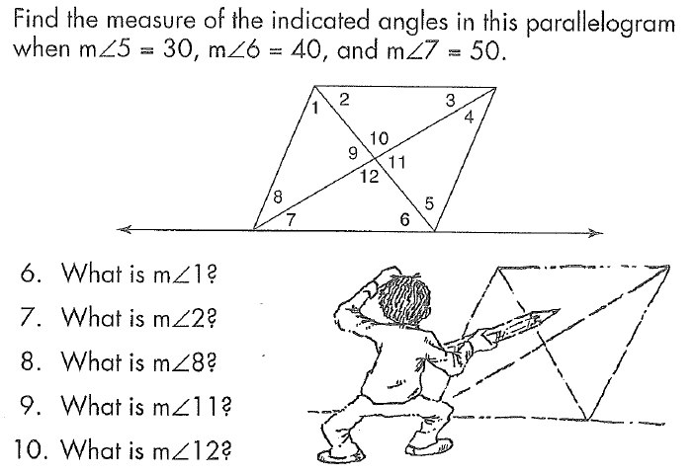9. 10. The following is a paralleogram.

JK = 10 cm, MK=21cm, JN=12cm, JM =23cm

Find the measures of the following segments:

KL = __________

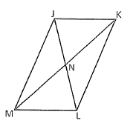

LM = __________

JL = ___________

NL = __________

MN= __________

KN = __________

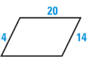

y

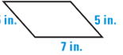11. 12.

X

X

**Directions:** Use the Pythagorean Theorem or Distance Formula to find the distance of each segment, and then find the midpoint of each segment and slope. You must simplify radicals and fractions!!!! You must show all work for each problem.

y

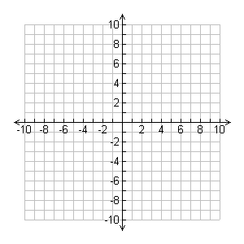

13. A(-4,2), B(8,-6) Distance: __________

Midpoint:___________

Slope: _________