Parallels Cut by a Transversal HW Day 1
Directions: Use the figure to compete the following:
1. Highlight the transversal
2. Name the parallel lines n and k

Directions: Use the figure to name the relationship between the two angles.
You must use only the following relationships:
Corresponding angles are congruent
Alternate interior angles are congruent
Alternate exterior angles are congruent
Consecutive interior angles are supplementary
Linear pairs are supplementary
Vertical angles are congruent

3. Angles 5 and 3 4. Angles 1 and 7

5. Angles 8 and 4 6. Angles 6 and 3

Directions: Use the figure to name the relationship between the two angles assuming the two lines are parallel and find the measure of the angles.
7. $If m<2=113°, what is m<6?$ 8. $If m<4=100°, what is m<6?$

m<6 = ____________________________ m<6 = ____________________________
Because: __________________________ Because: __________________________

9. $If m<1=84°, what is m<3?$ 10. $If m<7=75°, what is m<1?$

m<3 = ____________________________ m<1 = ____________________________
Because: __________________________ Because: __________________________

11. $If m<3=81°, what is m<6?$ 12. $If m<6=111°, what is m<3?$

m<6 = ____________________________ m<3 = ____________________________
Because: __________________________ Because: __________________________

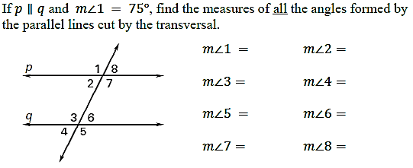
13.

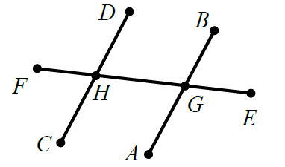
Directions:
If DC and BA are parallel, state if the angles are congruent or supplementary and why.

14.<DHG and <HGA

15. <FHC and <DHG

16. <BGE and <FHC

17. <EGA and <GHC

18. <AGH and <EGA

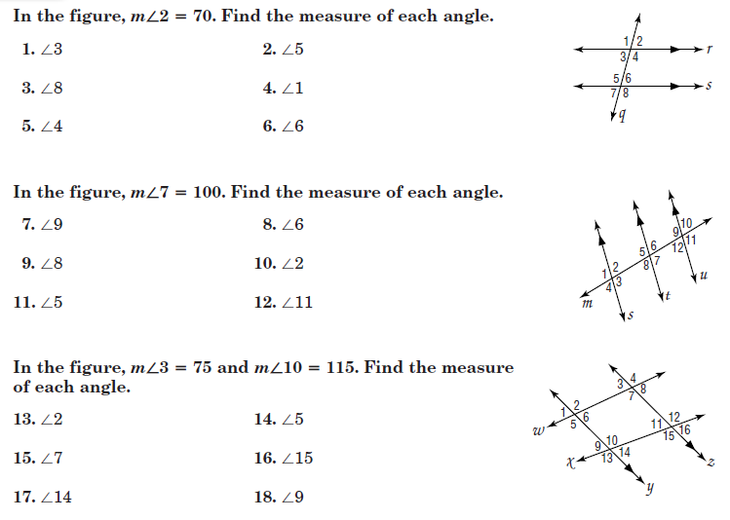

These are numbered weird because they came out of your book. Now you don’t have to take home your book… You’re welcome!
