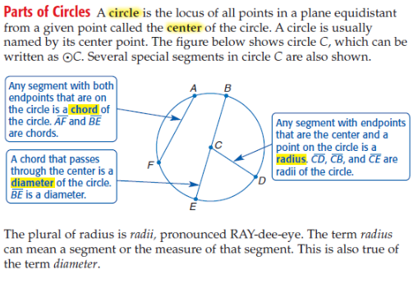
Parts of Circle Notes

Now you try ….
Example 1.
Name the circle:

Name a radius:

Name a diameter:

Radius = $\frac{1}{2}∙$ diameter Diameter =

Directions: Find the diameter, radius, circumference and area.
Ex. 2. Ex. 3. Ex. 4.

d=_______________ d=_______________ d=_______________

r=_______________ r=_______________ r=_______________

C=_______________ C=_______________ C=_______________

A=_______________ A=_______________ A=_______________

Ex. 5. Find the radius and diameter when the circumference is 22π.

d=_______________

r=_______________

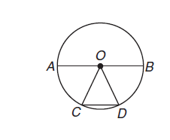
1. Parts of A Circle Independent Practice:
a. Name the circle. b. Name the radii of the circle.

c. Name the chords of a circle. d. Name the diameter of the circle.

Directions: Find the diameter, radius, circumference and area.
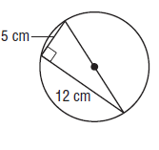
2.

d=_______________ r=_______________ C=_______________ A=_______________

3. Find the circumference of a circle with the radius of r=3$\sqrt{2}$. Use exact values.

4. If the radius of a circle is 4 what is the diameter and what is the circumference?

5. If the diameter of a circle is 6, find the radius and circumference.

What is the Central Angle?
The sum of the measures of the central angle of a
circle, with no interior points in common, is __________.
$m<1+m<2+m<3=$
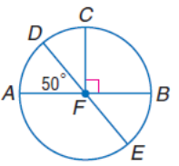
Example 6. Arc Measure: Find the $m\hat{BE}, m\hat{CBE}, and m\hat{ACE}$
$$m\hat{BE}=$$
$$m\hat{CBE=}$$
$m\hat{ACE= }$

Example 7. Find the measure of each arc.
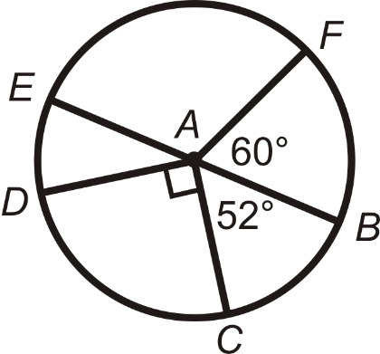
$m\hat{FB}=$
$m\hat{EC}=$
$m\hat{EFC}=$
$m\hat{FBD}=$

Arc Measure Independent Practice:

Recall: Arc Length.
With your shoulder partner, describe what arc length is and how you find it. Record your answers here.

Example 8: Find length of $\hat{QR}$
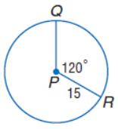

Arc Length =

Review of all concepts! (Together)
Example 9: If $m∠RPT=50°$, $∠SPT≅∠RPT$ the radius is 7.5cm. Find the following:
Name a diameter: _________________

Name a radius: _________________

D = __________________

Find the circumference: ______________________

$m\hat{MTS}=$________________________

Find the arc length of $\hat{MTS}=$________________________

Find the arc length of $\hat{MS}=$________________________

Review: Independent Practice:
1. If $m∠DOE=120°$, $m∠DOC=16°$, the radius is 12cm. Find the following:
Name a diameter: _________________

Name a radius: _________________

D = __________________

Find the circumference: ______________________

$m\hat{DBA}=$________________________

$m\hat{CB}=$_________________________

$m\hat{DBE}=$________________________

$m\hat{DC}=$________________________

Find the arc length of $\hat{DBA}=$________________________

Find the arc length of $\hat{CB}=$_________________________

Find the arc length of $\hat{DBE}=$________________________

Find the arc length of $\hat{DC}=$________________________

