**Acc Geo Name____________________**

**Section 9.6 Day 3**

**Draw the in resultant with the correct direction and magnitude.**

1.



2.

3

115°

139 m

68 m

4.

30 N

200°

35°

100 N

Show the following direction and magnitude on separate paper. Use drawings to scale.

5. Heading of S 25 W for 10 miles, then N 40E for 20 miles.

6. Heading of N50W for 15 miles then N50E for 10 miles

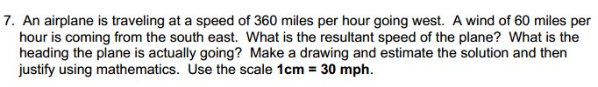

7.

8.

